Secular Franciscan Order July 2020 Newsletter

The Secular Franciscan Order was established by St. Francis of Assisi more than 800 years ago. Our purpose is to bring the Gospel to life where we live and where we work. We look for ways to embrace the Gospel in our lives and try to help others to do likewise.

If you haven’t ordered this yet, DO SO! It is an interesting historical read on the life, struggles and victories of a family’s journey through Polio in the 1950’s through the present day. These pages contain the story of courage, faith, trust, failures, comebacks, heartache, laughter, peace…. A gammet of emotional extremes. Karen’s remarkable telling and tribute to her cousin, George is a must read. Thank you, Karen for spending your pandemic time in such a life giving endeavor as to write an entire book! Contact Karen for an autographed copy of your own! Proceeds go to help pay for much needed care for George as he continues the battle of life. Kmp1103@yahoo.com

1
our Gathering
July 4th, 2020

Hope you were able to ZOOM right in! While waiting for everyone to connect, we began by sharing what has been happening on a personal level.
Alba Hernandez, OFS – welcome back! We’ve missed seeing your beautiful, cheerful face. So good to know your treatments have ended. We will continue to lift you in prayer.
Great to hear how everyone is coping with our current state of affairs.
Rather than collectively praying the Liturgy of the Hours, Mike & Dora began with the Saturday morning prayer “Joyful Simplicity” from the St. Francis Prayer Book. We then took turns reading from “Pray the Rule” by Liam McCarthy, OFM which emphasized points from different Articles in our Franciscan Rule book. Several shared their thoughts on what phrases resonated with them.
Mike shared updates from the Region as well as the JPIC Visioning 2 workshop that was held virtually with Regional JPIC Animators and our National Council. This will be integrated along with the Formation Visioning that has been ongoing as our Order continues to build upon what has been accomplished up until now as Formation remains a priority.
He also wanted to thank Alan & Ryan for sharing their knowledge and time with us and the Region in assisting people in better navigating Zoom!
At the Regional Executive Council gathering on June 13, 2020 in Lake Charles, LA, an agenda item included using Zoom for gatherings. There was; and still is some resistance to virtual gatherings, but it sure helped when we were able to get Ryan in Houston and Carolyn in Mississippi on the screen! The Regional Council later voted and agreed it was a worthwhile expense.
Additionally: Fabiola Cespedes, OFS and Alan Allen, OFS have agreed to serve as You Fra co-animators for the St. Joan of Arc Region. You Fra, is a separate entity than us; yet we as Secular Franciscans are bound, just as the OFM is to us, to serve them. They will be participating with other Regions and Nationally beginning July 13th via Zoom. Thanks Fabiola & Alan for stepping up and investing in our youth in this way!
Additional information will be forthcoming.
David & Mike gave an overview of JPIC, & David will be sharing actions we all can take, even when we are staying at home; such as writing letters, making phone calls, etc… Since this is an election year, our elected representatives will be more inclined to respond to constituents!
The Council voted to donate $1,000 to Amazon Relief (no relation to Amazon) which is a project of Secular Franciscans working together internationally. 100% of the donations go to serving the poor & spreading the Gospel in the Amazon! For more specific information, refer to the email sent by Mike Freeman, OFS on 7-3-2020.
A reminder was given that our elections are coming up soon and to prayerfully begin to ponder your personal call to serving in this fraternal life giving position. God doesn’t always call the qualified, BUT He always qualifies the called!
We then stopped and took a break.

Our guest, Benjamin Turk introduced himself. He is prayerfully considering joining our Secular Fraternity. He’s considered becoming a Franciscan or Jesuit priest/brother but due to family care giving obligations, he’s chosen the Secular charism. He thought if he had chosen a 1st Order, he’d be a Jesuit with the name Francis or a Franciscan with the name Ignatius. Welcome to our Gathering, Benjamin. Hope we have the privilege of getting to know more about you!
2
Mike read excerpts from The Franciscan Friars Holy Name Province “History Reflection for the 4th of July: How Prayer Underpinned American Independence” by Stephen Lynch. Discussion followed.
Next, Fabiola read “1846: Bishops Act of Consecration of the United States to Mary” from a blog by David Seitz, OFS (who represents OFS with Franciscan Action Network). David found this in “Manual of Prayers” published by the Pontifical North American College. Discussion followed.
Mike read portions of an emailed article from U.S. Catholic Magazine uscatholic.org: FAITH IN REAL LIFE
which appeared in the July issue (Vol. 85, No. 7, pages 16-18). The article focused on Fear as a pandemic our nation is facing, more so than Covid-19. Discussion followed.
Prayerful quotes from St. John Paul II, St. Padre Pio, St. Teresa of Calcutta & St. Elizabeth Ann Seton were prayerfully read. After each quote, time was given for personal sharing. Insightful quotes from the Saints are always beneficial to further our walk with Jesus.
David Schubert shared on the difficulties posed with prisoner’s lives during this pandemic and social distancing. Since visitation has not been allowed, he has been sending letters/notes to the prisoners on plain white paper (per Institutional Guidelines), encouraging the men with words of love and hope. He is unclear about the specifics of how the prison is handling social distancing and how much the prisoners are isolated, so the letters/notes are so very important to help with morale. Email David if you’d like to send a personal note to anyone imprisoned. 1313davidsch@gmail.com
We read together this beautiful “Franciscan” Prayer from Franciscan Mission Service.
Our Gathering ended with our Closing Prayer from the Ritual of the Secular Franciscan Order, page 36.

3

Greetings Sisters and Brothers!
While this pandemic is actually from the end of last year we in Houston for the most part have been impacted for a bit over 4 months. Prior to our first stay at home order we were so blessed to have Br. Tim, OFM come and provide us with Our Lenten Day of Reflection. All of the Houston area fraternities participated as we came together Discerning the Call of the Holy Spirit.
On a sad note I would ask you to put a brother who was there that day into your prayers: Sir Arnoldo Saenz. Arnoldo (Ronnie) had at one time considered becoming a Friar and had visited our fraternity; yet work responsibilities had him working most Saturdays. He was a faithful servant until the end……former Grand Knight of KC, Extraordinary Minister of the Holy Eucharist, volunteer at St. Vincent De Paul, visitor to the V.A. hospital, and even though he was sick he stayed afterward on the Day of Reflection to help clean up! God Bless you Ronnie!
As things were improving in our area we were finally able to come together in person in June which began with the Holy Mass and the long delayed Professions of Eileen and Phyllis, our fraternity gathering, and the Admission of Carla, Clair, and Veronica.
The spiked enemy became stronger and our July gathering was virtual. I suspect it will be this same way in August. So……Zoom, Zoom. Zoom. Please refer to the article in the latest TAU regarding meeting virtually…..it’s right on time!
Ryan and Alan have helped so much with our virtual gatherings. They have also been helping the Region with becoming familiar with this. If it is not mailed to you (all candidates and professed should receive automatically) it is available on the OFS USA site. As was discussed a few months ago, please visit that site often! There is so much on it.
For those who were not able to gather on the 4th we missed you! We were joined in cyberspace by Benjamin who is checking us out. Welcome!
Formation has been and remains a priority not only locally but throughout our Order, not only initial but On Going. The St. Joan of Arc Region has been working with members in our Region and OFS USA on this as has JPIC.
As I write this, Alan and Fabiola have stepped forward and agreed to serve as Co-Animators for the Region for Youth and Young Adults (YOU Fra) as OFS USA continues the Visioning!
This Visioning was started in earnest when all branches of our Franciscan Family came together in St. Louis for our first Visioning Gathering which had Fr. Dave Pivonka, T.O.R. as the keynote speaker .The Wild Goose took off!
We will soon have a standard for Formation throughout our Order which will strengthen us .
When Dora and I began our initial Formation Catch Me a Rainbow Too was the main resource. The FUN manual came out as a tool, which it will remain. The next book by Fr. Lester Bach, OFM was The Franciscan Journey which became the replacement. It then had an update. Fr. Bach lived long enough to see the fruits of his labor!
There was not a lot of difference in the two, other than reference to OFS instead of SFO in places, and an appendix.
4
For our next gathering we will use Ch. 32 of The Franciscan Journey and also the appendix. I will scan the appendix and send to everyone as it is so good, and titled “Dialogue & Debate”. (a copy is also at the end of this Newsletter)
If you do not have The Franciscan Journey there is a neighboring Region that has a wonderful resource on it here:
https://sfojuandepadilla.org/.. Go under the banner “Formation” and you will see it.
See you in August!
Peace
Michael

5
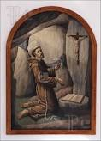 Remain in prayer for:
Healing prayers for Michael Freeman, OFS & his diagnosis of prostate cancer
Prayers of healing for Alba Hernandez, OFS – finished treatments! Scan scheduled 8-17-20
Healing Prayers continue for Joan & Deacon Louis Horr
All Poor Clares in New Orleans, especially Sr. Julie Glaser, OSC who tested + for COVID-19

Next VIRTUAL Meeting: August 1st, 2020
ZOOM TIME: 10:00 a.m.
Candidates & Inquirers in Formation: Check your email from your group coordinator for details.

PLEASE continue to Wear A Mask & Wash Your Hands!
Alba ordered some F.U.N. Manuals (For Up to Now – Foundational Topics for Initial Formation). They do not come with a binder. Purchase price is $13/ea.

$$$ Continue to save money for our contribution bag!
Cash or checks made payable to: St. Maximilian Kolbe Fraternity.

6
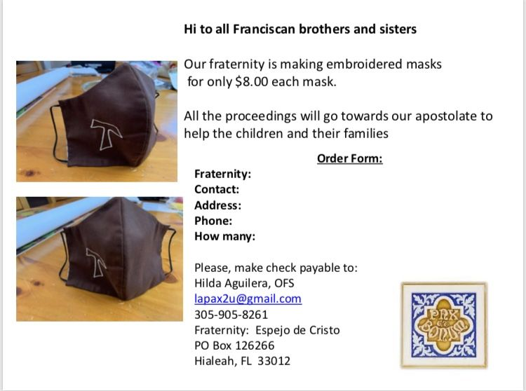

Every Day for PRAYER!

Who is my sister? Who is my brother?
A Response to Catholic Social Teaching with Sr. Maureen O’Connell
Online Event: 7-28-2020
10am-12pm CST
$30
Sponsored by Emmaus Spiritualit Center

World Day Against Trafficking in Persons
July 30th, 2020
1pm EST
Login: bit.ly/WDATrafficking
Phone: 917-338-1451
Passcode: 312252624#

There are LOTS of ways to become involved. See the 7-16-20 email from secretary.StMaxSFO@gmail.com for more details.

7
20th Quinquennial Congress 2021
Phoenix, AZ
August 18-22, 2021
THEME: Jubilee
“To celebrate and renew our Franciscan calling in the spirit of conversion”
Early Bird Registration: 8-18-20 through 12-31-20
$350 pays for meals, packet & conference expenses
Hotel Reservation Sheraton Phoenix Downtown: $89 plus tax/night (1-4 persons)
2 Queen beds or 1 King
Secularfranciscanusa.org or
www.quinquennialcongress.org

For more specific info, see emails from secretary.StMaxSFO@gmail.com

8
I Can See Clearly Now

“You are my hiding place; you will protect me from trouble and surround me with songs of deliverance.”
Psalm 32:7 (NIV)

Our African Safari had meandered through the bush when a flat tire stranded us.

“I need everyone’s help,” said the guide.

We dug sand from around the wheel and replaced the tire.

I wiped my forehead and looked around. The glaring sun made it hard to see anything. I put on sunglasses and noticed six lions lying in the shade just twenty feet away.

I called, too casually. “We have company.”

The guide looked up as a lioness stood and sauntered toward me.

“Into the vehicle,” the guide commanded. “As long as you’re inside, animals can’t tell you apart from the jeep.”

We all jumped in, but my shoulder hung perilously just outside the roll bar.

“She’s just curious,” the guide reassured us.

What if this is a smart lion and knows the difference between metal and my delicious tender red meat?

All of a sudden, the lioness turned around and plopped down under the tree.

As we made our way out of the bush, I pondered. What if I hadn’t put on my sunglasses to see the danger? How might it have gone?

Prayer is often like a pair of UV-reducing shades. I can see things much clearer after spending time with God. He is always my protector and deliverer. Satan may be like a roaring lion, seeking to devour us. But with Jesus as our strong tower, nothing can touch us.

Heavenly Father, I can’t go it alone in the jungles of this world. Help me discern the enemy watching – waiting. Cause me to run to you for protection and wear the full armor of God. Amen!

Author: Tez Brooks
Guideposts - All God’s Creatures
Daily Devotions for Animal Lovers
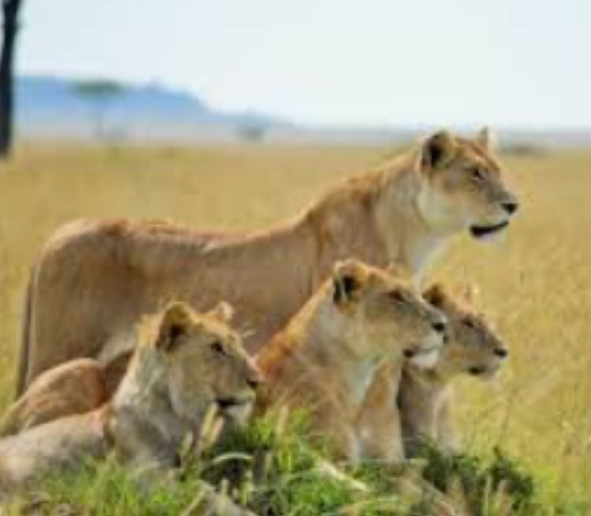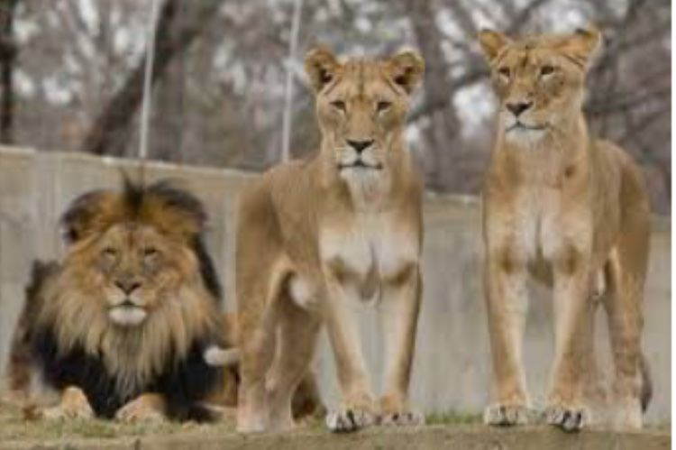
“Those silly humans think we can’t tell the difference between them and the vehicle? That’s a good one, hun!”

8

Sharing an Appendix in the updated version of The Franciscan Journey not included in older versions. Good information to have……

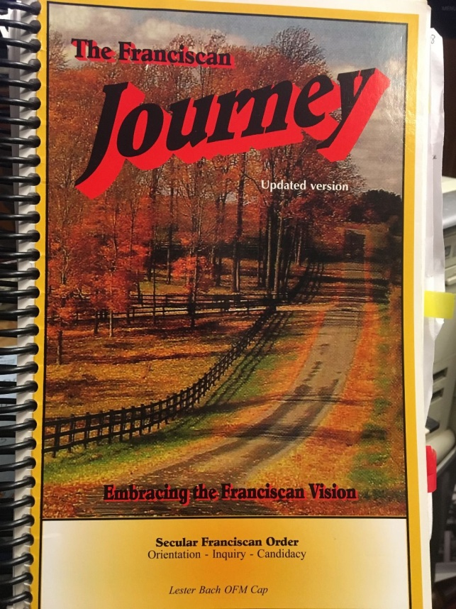
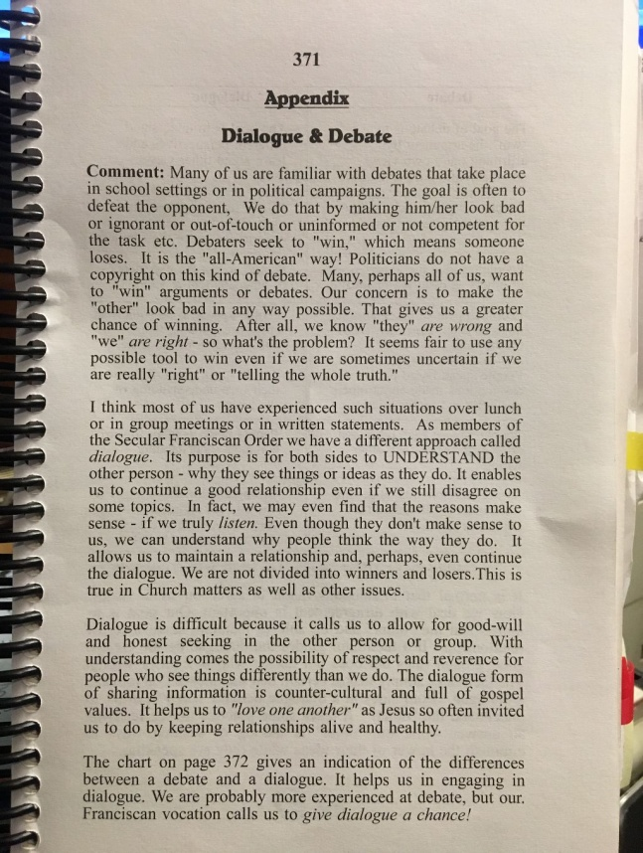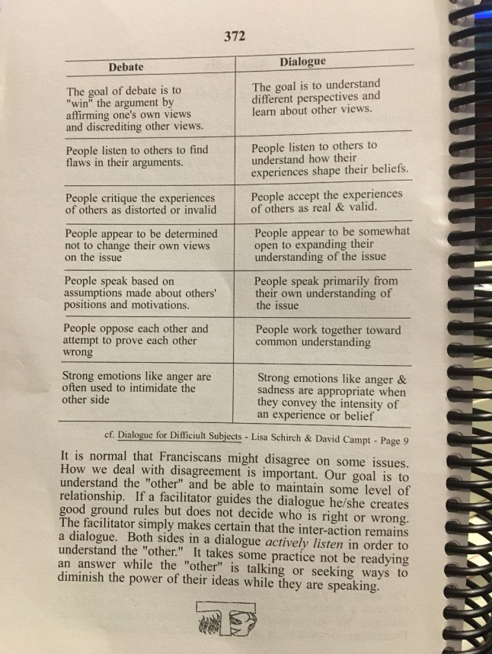
Mike will be scanning this and sending as a separate email to everyone.
9

