Secular Franciscan Order May 2018 Newsletter

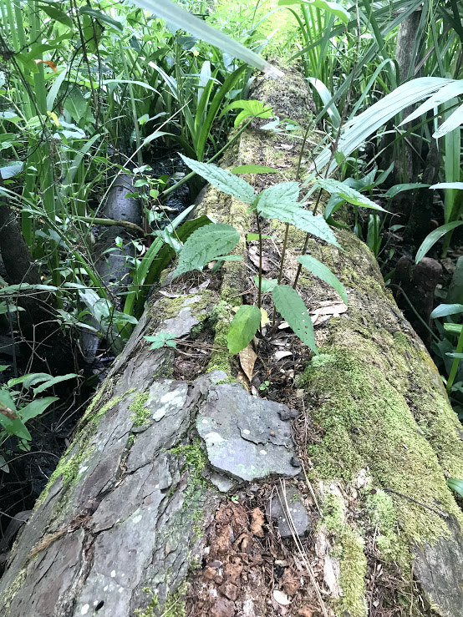 Ryan Efaw pic
Hopefully you all have had a chance to read the recap of our wonderful retreat in Louisiana compiled by Cherryle Fruge, OFS, our Reginal Minister. The plethora of pictures were taken by Valerie Laubacher, OFS – Los Tres Comaneros Region & several by Ryan Efaw, OFS. The main points of our “Secrets to Perfect Joy” retreat that I remember were from our speaker Fr. John Bamman, Conv. OFM who used the word J.O.Y. S.
J = Jesus; O = Other; Y = You; S = Service Jesus is FIRST. Other is SECOND. Yourself is LAST. An easy way to apply and remember the importance of God’s pecking order.
The other concept that is not new is the God Hole in our hearts and only God can fill it. It was great to be reminded of how we try & fill that hole with stuff.
While we were soaking in all we could on Retreat, the rest of the Fraternity were gathered in prayer and fellowship in the Outback on May 5th, 2018. The discussion was led by Rachel Persicano, OFS on the topic of Our Blessed Virgin Mary and her effect on us. Sharing was also on St. Francis’ relationship with Mary. The Little Office of the Blessed Virgin Mary was recited. Fellowship and food was had by all in attendance.
PAX ET BONUM

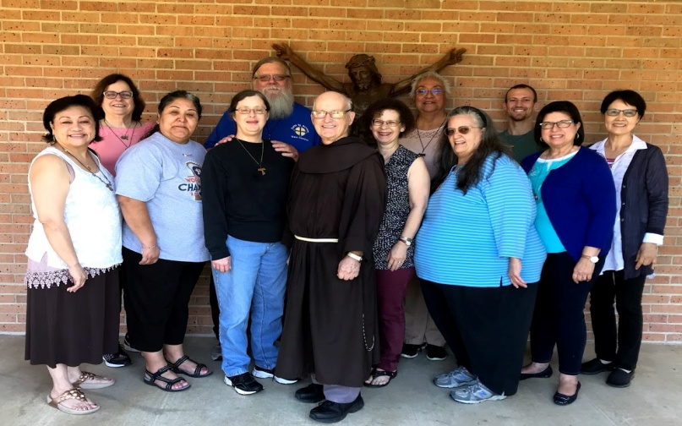
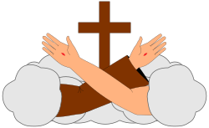
Answering the Call
In a recent communication from the Franciscan Action Network entitled, “A call to be the Fire of Love, Integrity, and Compassion” there was this quote from St. Catherine of Sienna “Be who you were created to be, and you will set the world on fire. ”I feel as if I could perhaps get a marshmallow a nice toasty brown, but set the world on fire?
This article by Sr. Margaret Magee, OSF, challenges the reader and asks if we are content with just remembering the past and what happened a couple of thousand years ago? It asks us “where and how do we experience the presence of Christ and the boldness of the Spirit today? Where and how do we experience the winds of life and goodness blowing new life in the places where the disciples of Christ gather? Where and how are we touched by the presence of Christ and the Spirit as if tongues of fire came down and rested on each believer? Where and how are we moved to go forth fearless and empowered to be witnesses and evangelizers?
My Brothers and Sisters, I strongly felt the Holy Spirit in action yesterday. All of the questions from the paragraph above were answered. We had 88 men in white for the Communion Service and 2 dozen after lunch for our Brothers of Francis meeting. I learn so much from these men as they witness and testify to the many things and ways the Holy Spirit has moved and freed them. One brother shared how he used to come to the services just to be with some of his buddies and would even make fun of those serving or in the choir…he considered them weak or fools. He patted the brother sitting next to him and said he used to get in his face and ask him why are you talking to me……he now openly says he loves him and how he is proud to be a Fool for Christ. This same man stated that in the free world he claimed certain streets and a neighborhood in which he did not even own any property, but now knows he will have a place in the Kingdom to come. Another who came into prison as an atheist was just confirmed this year by the Cardinal……..his initial reason for wanting to become a Catholic was the witness of one man who would spend all his spare time reading the Bible which gave him Peace in the midst of all that goes on in a prison.
I could go on and on as I get so much from serving these brothers. The Church has always had its share of detractors. The Catholic Community in Ellis and the men in white are no different in that they are a relatively small community in which there are so many detractors. For example, our next service may get bumped as the chapel will be used for Ramadan, the protestant churches have many more volunteers which allows them to offer additional services, than we do, but the Catholic Community is growing. Please continue to pray for those in prison or in the margins.
One of our apostolates as a fraternity is prison ministry. Prior to being canonically established in 2001, we were an emerging fraternity sponsored by the Annuniciation Fraternity. They had started going into Ellis. Jo Lovens and Rachel Persicano were among the first, followed by David Schubert. Please prayerfully consider joining with us on the third Saturday of every month as we take the Holy Eucharist and share the “Fire of Love, Integrity, and Compassion” with the growing Ellis Catholic Community. If you feel challenged or called please ask David, Connie, Danny or myself about what is required.
“Lord, send out your Spirit and renew the face of the earth”
Peace
michael

Next Meeting: June 2nd, 2018 in the Outback @ St. Jerome Catholic Church beginning 10:00 a.m.
Early Birds: An opportunity to join together in The Holy Mass in the day chapel @ St. Jerome beginning 8:15 a.m.
Candidates and Inquirers Formation begins @ 9:00 a.m. in the Outback

Ryan Efaw, OFS called Lois in Los Tres Campeneros Region who confirmed that the Fiesta Franciscana is again happening and it will be October 13, 2018 at the San Jose Mission (different spot than last year). Registration forms, etc. are not available yet....but mark your calendars for October 13......
road trip!

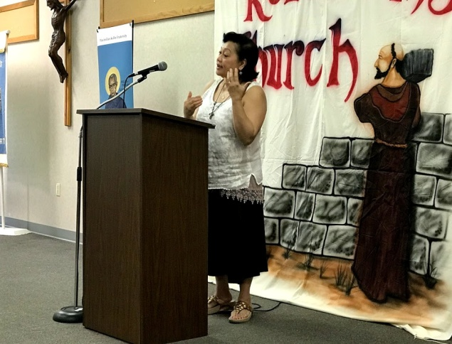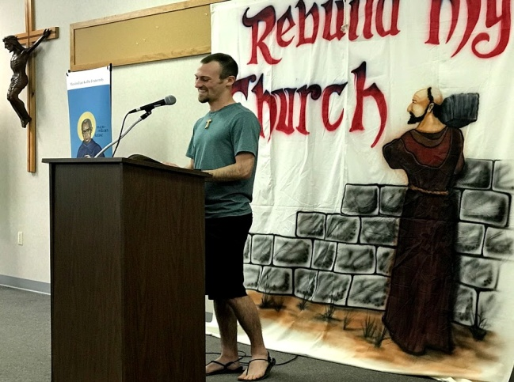

Amy Le Ryan Efaw

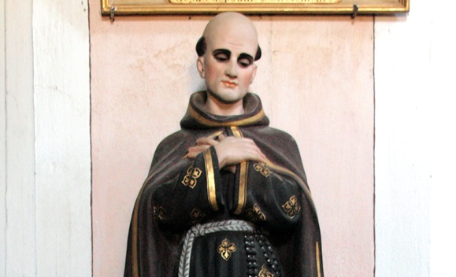

Saint Theophilus of Corte

(October 30, 1676 – June 17, 1740)
https://www.franciscanmedia.org/wp-content/uploads/2016/08/SODMay19.mp3
FOR MORE INFORMATION check out Franciscan Media!

Saint Theophilus of Corte’s Story
If we expect saints to do marvelous things continually and to leave us many memorable quotes, we are bound to be disappointed with Saint Theophilus. The mystery of God’s grace in a person’s life, however, has a beauty all its own.
Theophilus was born in Corsica of rich and noble parents. As a young man, he entered the Franciscans and soon showed his love for solitude and prayer. After admirably completing his studies, he was ordained and assigned to a retreat house near Subiaco. Inspired by the austere life of the Franciscans there, he founded other such houses in Corsica and Tuscany. Over the years, he became famous for his preaching as well as his missionary efforts.
Though he was always somewhat sickly, Theophilus generously served the needs of God’s people in the confessional, in the sickroom, and at the graveside. Worn out by his labors, he died on June 17, 1740. He was canonized in 1930.

Reflection
There is a certain dynamism in all the saints that prompts them to find ever more selfless ways of responding to God’s grace. As time went on, Theophilus gave more and more single-hearted service to God and to God’s sons and daughters. Honoring the saints will make no sense unless we are thus drawn to live as generously as they did. Their holiness can never substitute for our own.
Being a peacemaker can be thankless – even dangerous! That’s why people still look up to Francis of Assisi. He embraced “the other” with open arms and an open heart. In their faces, he saw the face of Christ.

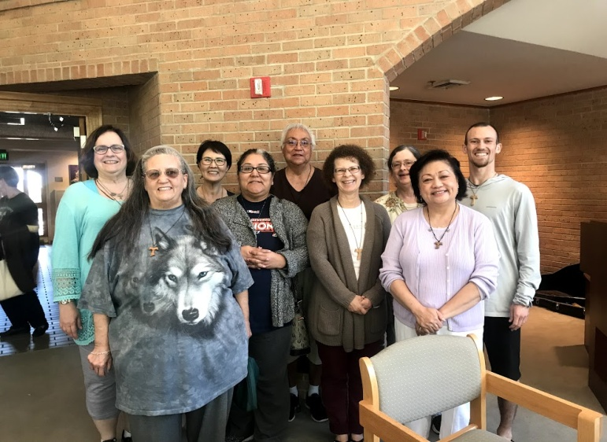
Phyllis, Eileen “Ike”, Sophia, Alba, Connie, Cindy, Dora, Amy, Ryan

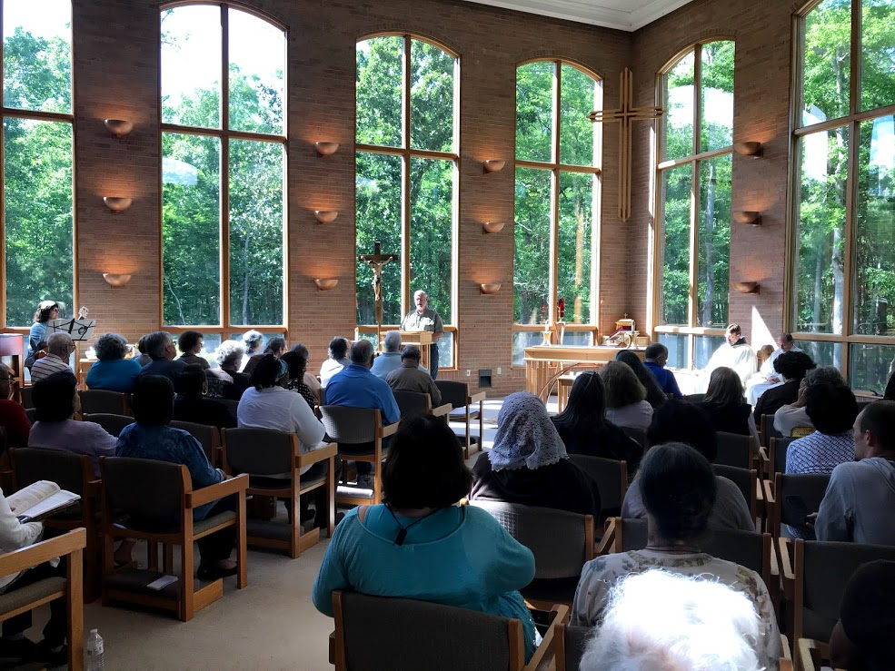
The chapel was an exquisite combination of God’s handiwork in nature & human artistic endeavors.

