Secular Franciscan Order September 2020 Newsletter

The Secular Franciscan Order was established by St. Francis of Assisi more than 800 years ago. Our purpose is to bring the Gospel to life where we live and where we work. We look for ways to embrace the Gospel in our lives and try to help others to do likewise.

“Science can purify religion from error and superstition;
religion can purify science from idolatry and false absolutes.
Each can draw the other into a wider world, a world in which both can flourish.”
St. John Paul II

1
our Gathering
September 5th, 2020

We began our Gathering with Eileen Ike Colleton reading the opening prayer which had been read at every session of Vatican II.

Dora read a brief passage written by Ilia Delio OSF from the book: “Compassion: Living in the Spirit of St. Francis”. Sr. Delio wrote: “Francis entered the world of the stranger and made the stranger into a brother. He learned to love what was weak and fragile, and learned to care for what the world discarded”. What a powerful and thought provoking reflection. Sharing & discussion followed.

We than prayed together the Opening Prayer, pg 35 from our Ritual book.

Alan Allen graciously facilitated our ability to watch a wonderful YouTube video produced by David Seitz, OFS on Living the Rule, a reflection on being a Secular Franciscan. The video was about 25 minutes in length, chock full of ponder worthy ideas. A great discussion/sharing ensued.

We then took turns reading from an article that was originally featured in TAU-USA in the Fall of 2018 entitled Part III: A Gentle and Courteous Spirit. This article prompted genuine dialogue as we each could relate to the lack of a ‘gentle and courteous spirit’ in social media and what each of us personally try and do to avoid falling into the clutches of such. For those who do not receive the TAU, it had been sent as an attachment, and it is also available on the National website.
We then prayed the Litany in Honor of Saint Roch and added our own personal intentions.

All of the readings, videos, prayers today just seem to flow - connecting thoughts that seemed to build on one another. It was a “God Thing” to be sure. If you were unable to attend the Gathering, please make sure you take the time to view the video. It was sent as an attachment from secretary.StMaxSFO@gmail.com via Michael Freeman’s email on 9-5-20.

Our Gathering ended with our Closing Prayer from the Ritual of the Secular Franciscan Order, page 36.

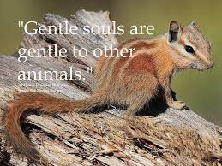

2

Greetings Good People!
It’s almost been another month since our last gathering and it seems like forever since the last time we were able to come together in person. I am so happy that most of us will be able to come back together in person for our October gathering, and with Alan and Ryan’s help, we will also be using Zoom for those who cannot be with us in person.
We will not be in our regular space at St. Jerome’s since it is impossible to maintain appropriate physical distancing in the outback so we will once again be in the Fr. Raye Center (the old church building).
As the upcoming election has upped the negativity and anxiety levels let us try and remember the acronym that was in that article from the TAU entitled, “A Gentle and Courteous Spirit”. Remember, it was T-H-I-N-K. We should strive to think before we speak or write. T-H-I-N-K: is it TRUE? Is it HELPFUL? Is it INSPIRED? Is it NECESSARY? Is it KIND? The sentence immediately following this was “Most importantly, let us pray”!
All we do as Christians, Catholics, and Franciscans should be guided by the Holy Spirit and it always begins in prayer. In October we begin with the Transitus of our Seraphic Father Francis in which he embraced Sister Death; followed by his Feast Day. I am sure I am not alone in that during this pandemic I have been made more aware of my own mortality. My diagnosis of prostate cancer was scary, yet the prognosis was good. It was especially comforting to me that the day I received my diagnosis was the same day the Pope announced he was going to beatify Fr. Michael J. McGivney, the founder of the Knights of Columbus who died most likely from complications of the 1918 pandemic. I am also grateful that I, unlike my father, who was blackballed for refusing to accept organized crime getting an additional seat and control on the union’s executive board, was able to retire and maintain insurance for myself and Dora until she reached the magic age for Medicare. I cannot help but feel sadness for the families of those whom have died being subjected to the constant focus on how it was all mishandled, etc… and will probably never know why, and for all those without decent medical care which in this greatest country in the world has become a political hot potato.
Yet I must T-H-I-N-K. I must constantly take that Franciscan pause before I speak or write. My ego wants me to blurt it out, as I know in my mind its true, and yet, is it necessary? It will not likely change anyone’s actions or mind, and conflict is never kind.
I even tell myself angst is not so bad, yet it robs me of the Peace Christ brought and which Francis wished to all whom he encountered.
Often these days, I turn to the prayer written or popularized by the Protestant theologian Reinhold Niebuhr, which has also been adopted by most 12 Step Programs.
The Serenity Prayer
God, grant me the serenity to accept the things I cannot change,
The courage to change the things I can,
And the wisdom to know the difference.

Amen!
Peace
Michael 3
Next Meeting: October 3rd, 2020
10:00 a.m.
St. Jerome’s Fr. Raye Center
(Same building we met in after Phyllis & Ike’s Profession.)
Candidates & Inquirers in Formation: 9:00 a.m. in the Fr. Raye Center
There is no 8:15 a.m. Mass on Saturday at St. Jerome’s.

PLEASE continue to Wear A Mask & Wash Your Hands!
We are continuing the SUNDAY Meal Sign Up for Deacon Louis & Jean Horr.
See email on 9-24-20 from secretary.StMaxSFO@gmail.com

Alba ordered some F.U.N. Manuals (For Up to Now – Foundational Topics for Initial Formation). They do not come with a binder. Purchase price is $13/ea.

$$$ Bring all that money you’ve been saving for our contribution bag to our
10-3-20 live and in person meeting! Cash or checks made payable to: St. Maximilian Kolbe Fraternity.

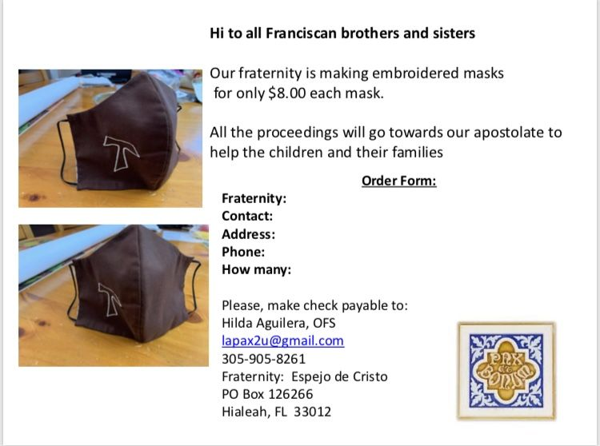 4
A Spanish version of the TAU-USA is now available and being mailed to Spanish speaking members upon request. Email your name, address, fraternity name & region name to:
Cindy Wesley OFS, cw93444@gmail.cm
Or mail request to:
Cindy Wesley OFS
846 Calimex Place
Nipomo, CA 93444

Every Day for PRAYER!

There are LOTS of ways to become involved.
See the 9-24-20 email from Ryan @ secretary.StMaxSFO@gmail.com and the
9-29-20 email from Michael @ mbigfree@aol.com for more details

Next Meeting will be 11-7-2020

In the midst of so much that is wrong in the world, in this country, in the Church, make a list of what brings you deep joy on this feast of St. Francis. Sr. Marie Lucey, OFS

5
Our Deep Gladness

“For you created my inmost being; you knit me together in my mother’s womb. I praise you because I am fearfully and wonderfully made; your works are wonderful, I know that full well.”
Psalm 139:13-14 (NIV)

I’ve always been fascinated by sloths. Because I assumed they were lazy creatures that didn’t like to do much more than hang around eating, I would teasingly compare myself to a sloth when feeling a bit lazy or sluggish.

God made them move slowly so they can conserve energy. They’re doing exactly what they’re created to do.

I often wonder if I’m doing what God created me to do. Am I doing the work he called me to do? Am I being the wife, mother, daughter, sister, friend he wants me to be? And I wonder if I’m truly following God’s will or my own desires. So I pray, study God’s word, and try to follow God’s leading. I ask the Holy Spirit to guide me as I strive to find God’s direction. I want to do the work he has for me, and yet I struggle to love the people he places in my life. And I often feel as if I come up short.

I sometimes feel as if I’m moving as slowly as a sloth, unsure of where I’m going, frustrated that I’m spinning my wheels as I search for God’s guidance. But maybe I’m complicating matters. Maybe I actually need to simply slow down and listen, to look for where God is working and join him.

The place where God calls you to is where your deep gladness and the world’s deep hunger meet. Frederick Buechner
Author: Missy Tippens
Guideposts - All God’s Creatures
Daily Devotions for Animal Lovers

What did the Sloth say
while riding a turtle?
I’m created to be slow. What’s your excuse? Wheeeeee!!!!
6
Remain in prayer for:
Healing prayers for Michael Freeman, OFS & his diagnosis of prostate cancer
Thanksgiving Prayers of healing for Alba Hernandez, OFS
Healing Prayers continue for Joan & Deacon Louis Horr
Fr. Mike requests prayers for all who have died due to COVID-19 and all who have been infected
Claire Dwyer: pray for her daughter Shannon, suffering from anxiety & depression.
For all those who continue to be impacted by Hurricane Marco & Hurricane Laura
For Alan Allen, OFS who, due to the pandemic, has been laid off. Also pray for fellow coworkers who were affected by the layoffs. Pray for peace for their families and a quick reemployment.
Safe travel and good health for Fabiola Cespedes, OFS who is visiting her parents in Bolivia.
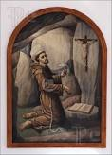

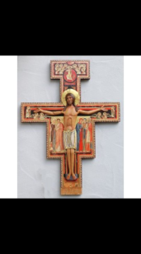

A Prayer Before the Crucifix
By St. Francis of Assisi

O God, sublime and glorious, come and enlighten the darkness of my heart;
Give me an honest faith, a firm hope and a perfect love;
by Your gift
may I feel and know Your holy will,
that I may obey it and not go astray.
Amen!
7

