Secular Franciscan Order
October/NOVEMBER 2018 Newsletter

The Secular Franciscan Order was established by St. Francis of Assisi more than 800 years ago. Our purpose is to bring the Gospel to life where we live and where we work. We look for ways to embrace the Gospel in our lives and try to help others to do likewise.

2018 is the 40th year of our current Rule approved in 1978!

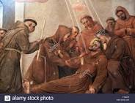
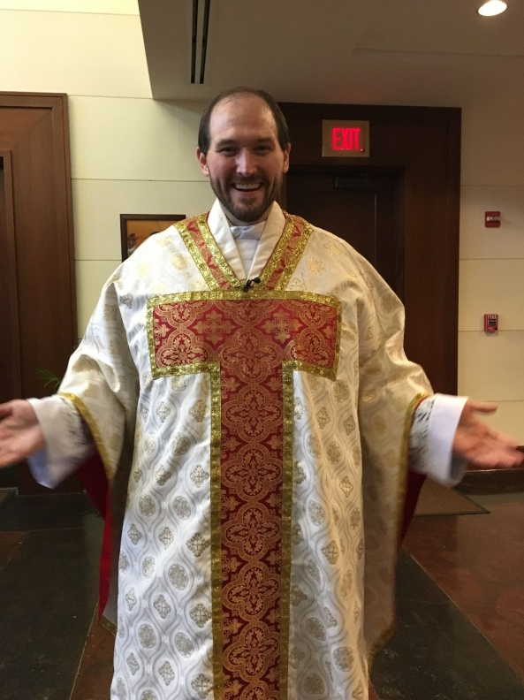
Fr. David Hust, St. Anthony of Padua Catholic Church

Eileen “Ike” Colleton was able to attend the Workshop given by Dr. Scott Hahn on 9-29-18. After the Workshop, Fr. Hust celebrated the Holy Mass for us. He is newly ordained and a Franciscan! I’d never seen a Chasuble with the Tau before.
Isn’t it beautiful?

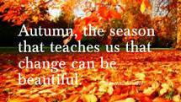

Our Gathering
October 6, 2018 St. Maximilian Kolbe Fraternity Meeting was held in The Outback at St. Jerome Catholic Church. We began with a traditional reading of the Commemoration of the Transitus of St. Francis of Assisi to Eternal Life. Our candle prayer for the three orders, past present and future was beautifully incorporated into the script. It was a real gift to those of us who’ve never experienced this holy tradition.

We then prayed from the Ritual of the Secular Franciscan Order, page 35 which lead into the Renewal of Secular Franciscan Commitment for those who are Professed.
Dora Freeman, OFS read a moving and emotional account of a Leper on the road to beg for alms. This came from an old article in the TAU. A thought provoking discussion followed. Many present requested a copy so one has been provided for you at the end of this newsletter. Get a hanky before you start reading…..
We were blessed to have Shelly come to this celebration and she brought relics of St. Francis and St. Claire for our veneration and added to this celebration. What a treat! Let’s remember to keep her, Gigi, and Adelle in our prayers.
Our Formation Director Dora reminded those seeking Profession to write a letter to Michael our Minister asking to be professed. It should be heartfelt as to why and include what you have found on this journey and what you can bring to the Order.
Following our gathering we completed our quarterly apostolate and those that could stayed to fill bags of toiletry items for Casa Juan Diego which were delivered the following Monday.
Note from Michael: Due to a myriad of issues I was not able to finish the October newsletter despite getting the draft from Eileen early……….so it is combined with November.

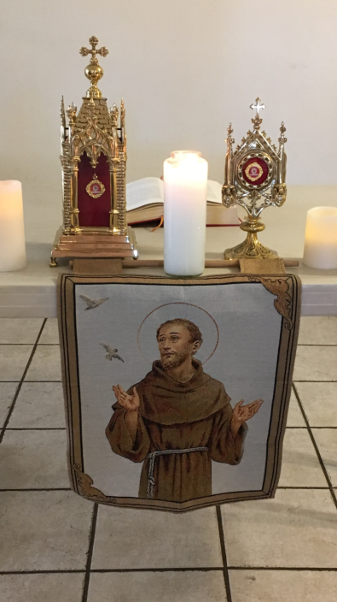
Relics of St. Francis of Assisi & St. Claire of Assisi

November 3rd, 2018 St. Maximilian Kolbe Fraternity monthly gathering was held in The Outback at St. Jerome Catholic Church. Joe Swonke, OFS, began our morning with leading us so beautifully in the Morning Liturgy of the Hours.
Alan led us with a Franciscan reading from St. Francis’ Testament. Reflection and Discussion followed. Barbara Landry, OFS, prayed the Candle Prayer, bringing to mind all Franciscans, past, present and future. Minister Michael Freeman, OFS, led us in the Opening Prayer, page 35. He then read from a synthesis of homilies by Franciscan Friars on All Souls and asked for our thoughts on who in our lives, deceased, made an impact in our Spiritual development as children of God. Heartfelt sharing and discussion followed. We then had the joy of witnessing and participating in the Ceremony of Introduction & Welcoming of Dori Ellis who has expressed an interest in our Franciscan way of life. Consuelo Davis OFS introduced Dori and we are so pleased to have her join with us.
After the ceremony, Minister Michael Freeman, OFS announced a short break to enjoy the delicious refreshments others brought to share.

After refreshments, we had a short business meeting. Ryan volunteered to keep track of the items we will each be donating to the Seafarer’s Center this Christmas. We will compile the boxes at our December gathering.
Mike spoke to us about the screening of the new movie about the life of St. Francis entitled “Sign of Contradiction”. Our fraternity is sponsoring this movie which will be shown on Wednesday, November 28th at the new Parish Activity Center. We agreed that some pre-packaged snacks (popcorn and/or chips) and bottled water will be sufficient for snacks; Cindy volunteered to obtain those for us. We will sell the snacks and any funds made will go to the Parish Activity Center fund. Dori volunteered to greet and/or help clean up afterwards. Let’s all pitch in to make sure this is a special night.
Mike reminded everyone about the establishment of the emerging fraternity of St. Elizabeth of Hungry Saturday, November 10th at 10:30 a.m.

Dora continued the lessons on the Articles of the Rule. She presented information concerning Article 8. Emphasis was placed on our participation in the sacraments, especially the Eucharist. She spoke about the importance of our prayer life. Contemplation is to be the “soul of all we are and do”. If we are to achieve intimacy with Jesus, we must communicate with Him daily. It is a most important part of our Franciscan way of life.

In continuing our study of the Rule, in January, Alan will present information covering Article 9, and Danny will cover Article 10. The following month, Cindy will present Article 11; Maria Article 12. (We are aiming to have Profession in February if all works out – if so, Cindy & Maria can make their presentations in March.)

Dora then led us in a meditation/contemplation which Mike brought back from the National Visioning Workshop. This focused on Mary anointing the feet of Jesus with the aromatic nard. We placed ourselves within the story from John 12:1-3. Then we pondered the gifts God has given us and how we wish to serve Him; how we wish to use our gifts for the good of each other, our fraternity, and the whole world. We wrote the name of the gift we wish to present to Jesus and sealed it into an envelope to be placed before the Christmas creche.

Finally, from the Handbook for Animators of Justice, Peace and Integrity of Creation (JPIC), we prayed the OFS Rule.

We had a discussion on what J.P.I.C. is and we will continue using the animators guide during our ongoing formation.

Rebuild my Church

Greeting Good People!
At our October gathering we renewed our profession as Secular Franciscans. During our profession we promised three times that this is what we wanted. We are a community, a true religious order. We committed to “follow Christ in the footsteps of Saint Francis of Assisi” The Holy Spirit called each of us to share in the Charism of our Seraphic father Francis. We accepted the Rule.

How are we doing with this?

So often we tend to forget or lessen the promises we make during profession. We find multiple excuses for not participating within the fraternity and for not serving. This past weekend many of us celebrated with our Brothers and Sisters as the St. Elizabeth of Hungary Fraternity was canonically established .What a beautiful event this was and it would not have ever happened without members saying “Yes” to the Holy Spirit. One sister has been driving from Austin for the fraternity meetings and is now even considering closing her business and relocating to Houston to be closer to her fraternity .The celebrant traveled from New York; and our Region was well represented by our Minister Cherryle, the provincial Spiritual Assistant Brother Juniper, our Regional Spiritual Assistant, Brother Dan, and several others who came over to our side of the Sabine.

The following is from a letter in the latest Tau from our International Minister, Tibor Kauser:

My dear Sisters and Brothers!
May the Lord give you his peace!
This year we are celebrating the 40th anniversary of the Rule of the Secular Franciscan Order, approved by Pope
Blessed Paul VI on June 24th 1978, with his letter 'Seraphicus Patriarcha'. It is the right time to set the question:
What is the Rule for me, in my personal life? What is the Rule for us, as an International Fraternity, on its all levels?
What does it mean for us to 'celebrate this anniversary', to celebrate the Rule?
Our Rule is not only a normative or legislative text, but also (and mostly) a spiritual text. It is to be read often not only because we have to keep some norms or do some pre-written prayers, but also and mostly because it is our treasure, that helps us to fulfill our vocation. It has to inspire us! We, Secular Franciscans, have everything in our Rule, that can give us enough inspiration to walk along the way of our vocational journey.
To celebrate our Rule is to make it live, only this way will we be faithful to the proposal of Jesus, who invites us to love one another as brothers. Francis of Assisi has given us the example of the grace of conversion as a great gift, which commits us to continue to follow the Franciscan path with courage and love. Our Rule, a truly Franciscan one, helps us to discover, how shall we live our vocation on a daily basis, what should our everyday life be like? We are not 'Sunday Franciscans' or 'afternoon Franciscans'.

The life of a secular Franciscan is not a uniform life. We are different. We have to raise our heads, open our eyes, and look around: how beautiful and rich this life is, that God offers us to live according to our vocation! I invite all of you to discover your talents and find inspiration from the Rule, how your daily life should be lived. Discover the richness of God, the richness of our vocation! Some of us feel certain articles of the Rule closer to him, while others feel others. For some of us certain articles seem to be easier to live than others. Yes, the Rule does not want to uniform us but to unite us in the diversity.
Go out, and find how you can live your vocation in the Church, in the society, among the poor, among the needy, among our neighbors in the family, at work, in the fraternity, in free time, in different ways reflecting on the same charism and the same vocation. Be inspired, so that you can inspire others! AMEN!
Let us continue growing individually and collectively as a fraternity as we continue to follow Christ in the footsteps of St. Francis!

Peace
michael

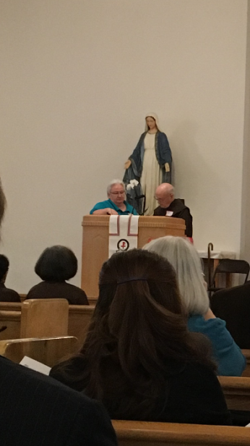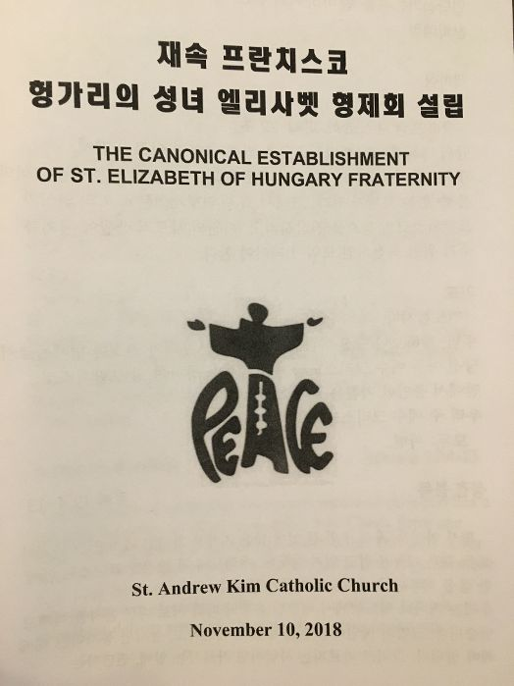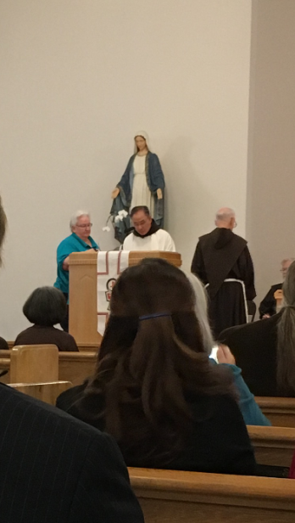

Next Meeting: December 1st, 2018 in the Outback @ St. Jerome Catholic Church beginning 10:00 a.m.
Early Birds: An opportunity to join together in The Holy Mass in the day chapel @ St. Jerome beginning 8:15 a.m.
Candidates and Inquirers Formation begins @ 9:00 a.m. in the Outback AND after our meeting @ noon!

St. Thomas More Fraternity is hosting a “Franciscan Retreat Day”
WHEN: Saturday, November 17th, 2018 from 9:00 a.m. to 4:00 p.m. in Houston.
FREE OF CHARGE but an RSVP is requested. Linda Hopwood, OFS lhop.lmh@gmail.com or call (713) 410-3424
TOPIC: “From Gospel to Life Within The Franciscan Charism”
RETREAT MASTER: Fr. Bernie Tickerhoof, TOR from Pennsylvania.
For more info on Fr. Tickerhoof, go to: http://www.franciscanstor.org/btickerhoofBIO/
WHERE: Holy Rosary Parish Hall - 3617 Milliam Street – Houston, TX 77002

Maximilian Kolbe Secular Franciscan Fraternity is hosting the Screening of a new film about
St. Francis: “Sign of Contradiction”
Wednesday, November 28, 2018 from 7:00 pm – 9:00 pm
St. Jerome Catholic Church’s new Activity Center
8825 Kempwood Drive - Houston, TX 77080
FREE but must have a ticket from evenbrite website
For more information, contact Michael Freeman

FOR MORE INFORMATION ABOUT EVENTS, PLEASE REFER TO E-MAILS FROM secretary.StMaxSFO@gmail.com

I finally did it! I bought a new pair of shoes with Memory Foam insoles.
No more forgetting why I walked into the kitchen!

I, A Leper - Vic Landry, SFO - Saint Joseph Fraternity - Baton Rouge, LA
I hate. These two words are the sum total of my existence. I hate what I am. I hate the disease that consumes my body from the extremities in. I hate the rags I arrange to hide the most hideous sores and corruption covering so much of my body. I hate the smell that draws the flies to lay their eggs in my wounds. I hate the bell I ring to let decent people know that a wretch like me is drawing near. I hate the hunger that knots my belly and saps what little strength I have. I hate the daylight that allows others to see what I am and causes the sweat to pour, stinging and burning, into my raw flesh. I hate the night when I huddle with other creatures like myself in the damp cave we inhabit, a hovel so disgusting no one unlike us can stand to approach from downwind. I hate my mother for giving life to a child destined for misery and reproach. I hate whatever unknown sin caused a boy of ten years to be condemned to year after year of fear and loathing. I hate this road I travel daily to beg for alms at the gate of Assisi. I hate the dust stirred by the horses of the lords and ladies that gallop past, their royal eyes averted and their perfumed scarves held to their noses. I hate them in their fine clothes and their fine houses with servants to tend to their every want. I hate the dogs that eat their scraps, a meal better than I will ever have. Most of all, I hate God for turning His face from me like everyone else.
In the distance I see a rider on horseback and I hear the pounding hooves - another wealthy young merchant's son on his way to squander his time on drink and carousing. I limp to the side of the road and turn my head, ringing the bell. I turn my head as much to avoid the look on his face as to avoid the dust from his mount. I hear the horse slow and stop. I feel the rider's eyes staring at me. I hold out my hand and cry for alms, hating myself for my poverty and him for his wealth. He approaches. A faint hope stirs in my breast; perhaps he will provide food or alms enough to shorten my journey. Or will he shorten my life with his sword? Could his loathing for my miserable form cause him to provide a merciful end to my life?
“Brother, look at me.”
I turn my head in response, looking through the rags that cover the ruin of my face. I see a small, slight young man with protruding ears and glittering eyes. The eyes - they gaze at me in a way I have not seen in these many years. How can this be? How can he stand to look at me with such love and compassion? They burn into my soul and enkindle a fire, long buried and smothered. What is this? He embraces me, wrapping his thin arms around my wretchedness, lifting me from the ground in his enthusiasm.
“God loves you and so do I. Peace and all good, my brother.”
With those words, he kisses me, slips some coins into my hand, leaps onto his horse and gallops away singing and laughing.
I stagger and crumple to the ground weeping and sobbing, the warmth of God's love coursing through my soul, displacing the knotted bonds of hate. Oh, Divine happiness! Oh, Divine love! My soul is redeemed and made whole. My rags are like the finest silk and my wounds feel as though they are treated with a divine balm. I sing songs of praise that I have not sung since my boyhood. I turn toward Assisi with renewed strength of body and soul and with enough alms to sustain my brother lepers and myself for months. Praise God and that young man!
