Secular Franciscan Order April 2021 Newsletter

The Secular Franciscan Order was established by St. Francis of Assisi more than 800 years ago. Our purpose is to bring the Gospel to life where we live and where we work. We look for ways to embrace the Gospel in our lives and try to help others to do likewise.

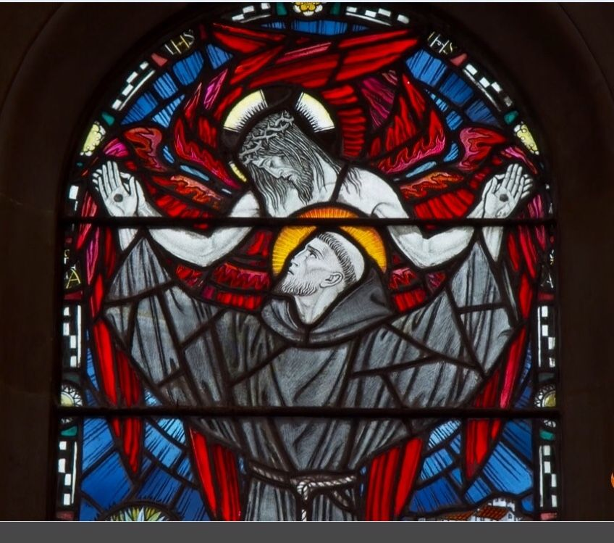

1.
Our Gathering
On April 4, we met virtually & in person, giving members a choice due to safety concerns relating to the pandemic.

Benjamin led us in the Candle Prayer as we remembered all past, present and future members of our Franciscan family. I always appreciate hearing the names of those who have gone before us and calling to mind those who cannot be with us.

We all participated in our Opening Prayer from our Ritual book, page 35.

For our Franciscan Reading, Dora read Admonition 5 from the Admonitions of St. Francis entitled: “In order that no one be proud, except to glory in the Cross of the Lord”. This translation came from the book: Becoming Holy, by Karen S. Woods. Discussion followed. We can only boast of these things, our weakness and sinfulness (2 Cor. 12:5) and that we daily bear the sacred cross of our Lord Jesus Christ (Luke 14:27). ALL GOOD comes from God alone.

Our Spiritual Assistant, Fr. Mike was unable to be with us this Holy Saturday as he was busy with the kids coming into the Church and administering the Sacrament of Reconciliation. Mike Freeman shared a reflection from: “ Daybreaks, Daily Reflections for Lent and Easter” by Daniel P. Horan, OFM. Discussion followed.

Ryan worked his magic and allowed us to view a video by Scott Hahn who read from an ancient homily for Holy Saturday. (A 5.06 minute video was emailed 4-2-21 from Mike if you’d like to view it again. Video was originally produced 4-11-2020.) Discussion followed. This ancient homily is included in the Office of Readings for Holy Saturday.

Dora led us in a guided meditation: (handout emailed 4-2-21) Contemplating the Day After the Crucifixion with the Mother of James & John. Discussion/Sharing followed.

Once again, Ryan clicked the magic button that allowed us to view and contemplate a video: Holy Saturday with Mother Mary. The video was filled with facts and speculations on Mary’s experience during Holy Saturday. We are called to ponder her ponderings. Discussion/Sharing followed.

We then enjoyed the song written by Leonard Cohen “Hallelujah”, with new lyrics written by Kelley Mooney. Benjamin Turk was kind enough to email the Easter lyrics after the meeting.

Mike & Dora reminded us about the importance of upcoming elections at our 5-1-2021 meeting. It was stressed how important it is for all to be in attendance, in person, for full participation in voting. Danny reminded us God doesn’t call the qualified, but qualifies the called. Remain in prayer about saying “YES” if called to service in this capacity.

We spent time sharing our need for intercessory prayer, lifting up our loved ones and those issues weighing heavily on our hearts for the mercy of God to be felt.

We ended our Gathering with the traditional closing from our Ritual book, page 36.

2
Greetings Sisters and Brothers
Happy Easter!
I saw this on the Poor Clares of Bellville site: www.poorclares-belleville.info/Fruits/Easter2.htm and copied 2 of the paragraphs and the prayer:
St. Francis of Assisi shows what can happen when the grace of Easter becomes effective in a Christian’s life. He teaches us that every earthly suffering holds the seed of resurrection.
For Francis, Easter was a vibrant reality that gave light and hope and even energy for his daily journey with Christ to the Father. He teaches us that the real saints (the Easter saints) are the quite human, quite natural people in whom, through the Easter purification and transformation, what is human appears afresh in its total originality and beauty. (Pope Benedict XVI)
St. Francis of Assisi,
Man of the Gospel,
Icon of the Crucified,
Easter Saint,
pray for us!
May the Hope, Joy and all the graces of our Risen Lord bless you now; forever and give you the energy needed in our world. His Holy Spirit guides and animates us. Jesus, I trust in You!
This will likely be my last blurb as elections are upon us. It has been such a blessing to serve as minister. I can say with no uncertainty it has deepened my personal conversion and allowed me to become a better Christian, Catholic, and Franciscan. Thank you all for putting up with me! There have been challenges yet nothing in comparison to the many graces received.
As many know I enjoy history. Our fraternity began this newsletter over a decade ago. Dora and I were in formation and she volunteered to do it to foster communication and dialogue. Valerie volunteered to take it over prior to her move to Austin which prompted Dora to start again. When Eileen volunteered to do it Dora was more than happy to pass it on!
Another avenue which has fostered communication has been Ryan’s weekly e-mail to us all on Thursdays!
3.
It is such an amazing thing to see our Franciscan fraternal bonds growing and knowing we are here for one another and also in our prayers!
Servant leadership is a defining characteristic of being Franciscan. Amongst the Friars they are all called Friars, whether they are Priests or Brothers. With Secular Franciscans all the professed have promised to serve. Let us share the gifts we have been given. And one does not have to be professed to serve…this is not our fraternity as we are all called to Rebuild His Church !
It is good to be familiar with all of our Essential Documents, not just our Rule. Within our General Constitutions we read:
Article 30
1. The brothers and sisters are co-responsible for the life of the fraternity to which they belong and for the OFS as the organic union of all fraternities throughout the world
2. The sense of co-responsibility of the members requires personal presence, witness, prayer, and active collaboration, in accordance with each one's situation and possible obligations for the animation of the fraternity.
3. Rule 25 In a family spirit, each brother and sister should make a contribution to the fraternity fund, according to each one's means, to provide the financial means needed for the life of the fraternity and for its religious, apostolic, and charitable works.
The brothers and sisters ought to provide the means necessary for supporting the activities and the operations of the fraternities at higher levels, both by their financial assistance and by their contributions in other areas as well.
Article 31
1. Rule 21 “On various levels, each fraternity is animated and guided by a council and minister (or president).” These offices are conferred through elections, in accordance with the Rule, the Constitutions, and their own Statutes.
What I have highlighted above is the same terminology we find in Instrumentum Laboris; this co-responsibility we are called to share in.
Our Election is still scheduled for May 1, 2021. We will not be Zooming that day as we need all to be present as elections cannot be done virtually.
Only permanently professed members have a vote, yet there are things that need to happen that voting members do not do. We will still be able to insure Covid-19 protocols are adhered to as we will again be spread out in the Fr. Raye Center.
Peace
michael

4.
Next Meeting: May 1st, 2021
10:00 a.m.IN PERSON ONLY. NO ZOOM due to elections
Candidates & Inquirers in Formation: check your emails for more information
Our Gathering will be IN PERSON
No Zoom

We are continuing the SUNDAY Meal Sign Up for Deacon Louis & Jean Horr.
See email on 11-19-20 from secretary.StMaxSFO@gmail.com

Alba ordered some F.U.N. Manuals (For Up to Now – Foundational Topics for Initial Formation). They do not come with a binder. Purchase price is $13/ea.

$$$ Continue to save money for our contribution bag!
Cash or checks made payable to: St. Maximilian Kolbe Fraternity.

Regional Crown Rosary will be prayed together via ZOOM each month on the 4th Sunday. If interested in being included in receiving ZOOM information, please contact Cherryle Fruge, OFS, Minister-St. Joan of Arc Region: cherrylefruge@msn.co

A Spanish version of the TAU-USA is now available and being mailed to Spanish speaking members upon request. Email your name, address, fraternity name & region name to:
Cindy Wesley OFS, cw93444@gmail.cm Or mail request to:
Cindy Wesley OFS
846 Calimex Place
Nipomo, CA 93444

5.

Every Day for PRAYER!

Fraternity Council Elections
May 1st, 2021

Living Franciscan Virtues in our Contemporary World
Secular Franciscan Conference
June 28 – July 1, 2021
$50.00

Funeral Mass for
Gabriel Harkay, OFS
Saturday April 17th, 2021 @ 1:30 p.m.
Prince of Peace Catholic Church (Mary Chapel)
19222 Tomball Parkway – Houston, TX 77070

There are LOTS of ways to become involved.
Reference emails from Ryan @ secretary.StMaxSFO@gmail.com and emails from Michael @ mbigfree@aol.com for specifics!

June 2021 Meeting will be 6-5-2021

6.
Jesus said, “I am the living bread that came down from heaven. Whoever eats this bread will live forever. This bread is my flesh, which I will give for the life of the world.”
John 6:51 (NIV)

“ARE YOU GETTING ENOUGH SUNSHINE?” my doctor asked. He may have noticed my I-work-at-my-desk-all-day pallor.

“I work at my desk all day,” I told him. “But I take vitamin D supplements.”

He looked at my lab results. “Your calcium is on the low side of normal. Are you eating enough dark greens?” “Not to worry, Doctor. I’ll take a calcium supplement, or two.”

This is how the appointment progressed in my mind as I prepared for my annual physical. I was compiling the list of medications and supplements, conscious that I was supplementing much of what the human body can normally get from a healthy diet and ten minutes of fresh air a day.

How often do we try to do the same with our spiritual health? We depend on supplements – someone else’s insights, Sunday’s sermon, a brief nugget heard on the radio – as our entire spiritual intake for the week. We lean on supplements rather than a rich diet of daily Bible reading, prayer time, and reflection with Jesus.

Jesus no doubt carried on a perpetual internal conversation with His Father, but He still stole away by Himself for extended times of prayer. He said we should “abide” in Him (John 15:7, NKJV), which seems more like a meal than a quick snack, doesn’t it?

Author: Cynthia Ruchti
Mornings with Jesus 2020
Daily Encouragement for your Soul

7.
Healing prayers for Michael Freeman & his diagnosis of prostate cancer

Healing prayers for Alan Allen’s 90 yr old Mother-In-Law who had cholecystectomy 3-30-21 & for strength for his Father-In-Law, his wife & her sister. May Alan be given the wisdom words & peace to comfort all his family.

Healing Prayers continue for Joan & Deacon Louis Horr

Dora’s sister, Suzanne is requesting prayers for her son, Dexter who is also Dora’s Godchild & Dexter’s friends, Jordan Servat, Reed Boudreaux & Layne Gravois. They were involved in a rescue attempt of other children caught in a rip tide in Destin. They ended up having to be rescued themselves, although, sadly, Layne Gravois drowned. The other two boys were hospitalized. Jordan is still in the hospital. Reed was released. An adult rescuer also died. Lord, we pray for emotional, physical & Spiritual healing for Dexter, Jordan & Reed & for the repose of the soul of Layne. May all family members feel Your love & peace. Give Your wisdom to the parents to know how to best comfort their distraught children. In your precious name Jesus, we pray.

Claire Dwyer: pray for her daughter Shannon, suffering from anxiety & depression.

Continued prayers for Alan Allen, his fellow coworkers & all seeking sustainable employment! Pray for peace, patience & renewed hope.

Pray for continued success for Alan & Fabiola in their ministry of YouFra.

Ryan Efaw, Caitlyn & child: Expected due date is May 24, 2021! Pray for good health for mother, child and of course, daddy! It’s coming up soon!!!

Pray for all Priests and Seminarians throughout the world.

Continued prayers for Martha Restrepo (healing of eyes), her Husband Holbein (cancer treatments) &
son in law Deacon Robert Trahan (bypass surgery & good heart health)

Fabiola requests prayer for her Confirmation sponsor Ian & his elderly parents (mum:cancer surgery/dad:possible dementia diagnosis & confusion while separated from his wife as she recovers).

Continue to pray for Mary Pierson & family as they work through their grief.

Pray for Benjamin Joseph Turk: ultrasound report: 5-6 nodules/cysts on his thyroid. Follow-up w/Endocrinologist scheduled for 4-19-21.

Pray for Shelley Barger & GG who are both in scooters, unable to walk. Shelley will be undergoing scans at the hospital. Pray outcome will be a favorable one.

Pray for Carla Lewton’s mother Barbara who has been steadily declining. Pray family will find a wonderful healthcare facility that will be agreeable to Carla, her two brothers & Barbara.

Remember to email Ike ecolleton@comcast.net for prayer requests to be included in Newsletter

Make sure you make room in The Rule for THE RULER!
8.

What caption would you put under this picture?

9.

