Secular Franciscan Order MAY 2019 Newsletter

The Secular Franciscan Order was established by St. Francis of Assisi more than 800 years ago. Our purpose is to bring the Gospel to life where we live and where we work. We look for ways to embrace the Gospel in our lives and try to help others to do likewise.

2019 is the 41st year of our current Rule approved in 1978!

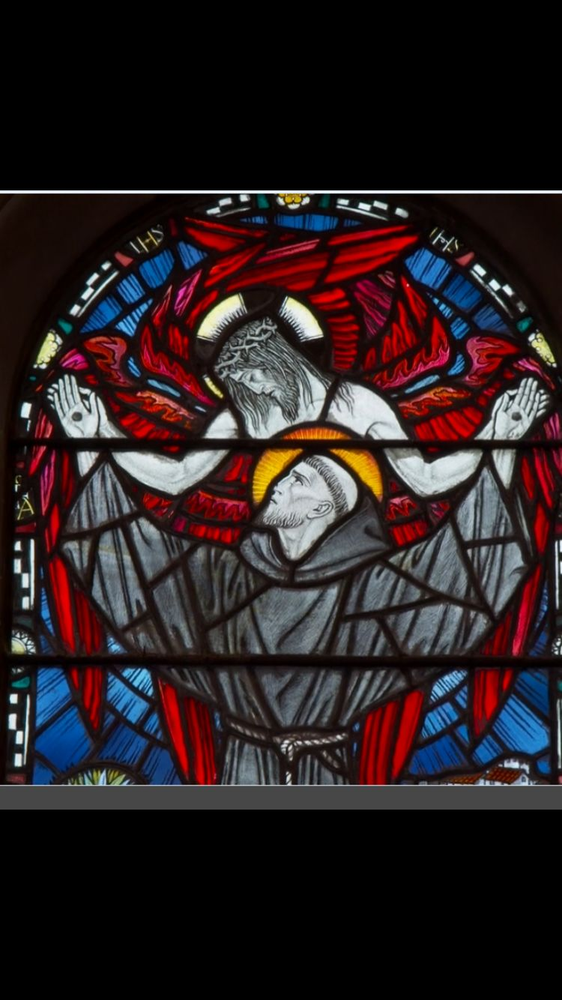

Our Gathering
May 4th, 2019 Joe Swonke, OFS; one of our elected councilors graciously offered to serve & lead our Gathering in the absence of so many of our Fraternity who were unable to attend due to our Annual Retreat in Louisiana.

A reading from the “official” biographer of Francis, St. Bonaventure was shared and discussion followed. A Marian meditation from Loyola Press was read in honor of Our Queen Mother Mary as May is her special Month. A version of the Scriptural Rosary was recited with a commentary on the Joyful Mysteries.

We had a visit from Maricela who hopes to visit again next month.

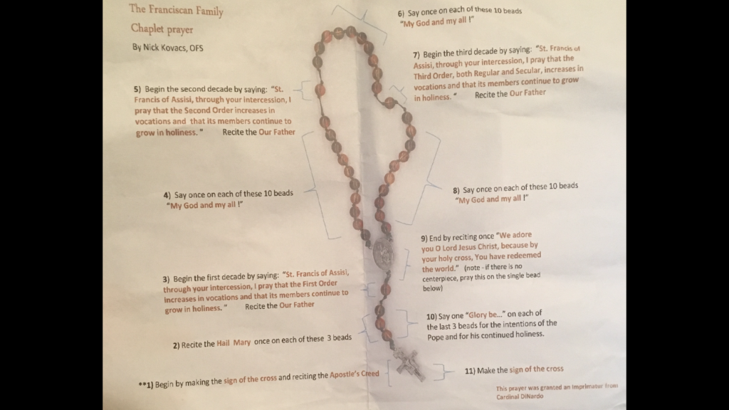

This is a beautiful prayer!

Focused meandering
The end of the school year marks the beginning of summer, regardless of what the calendar may say. Along with that we get the humidity, bugs, storm and family plans. Many in our Franciscan family will be traveling; and I hope and pray that these days will become happy memories with loved ones. I was so happy to hear how well the May gathering went; and if there was ever any doubt this fraternity is not anyone of ours but a privileged place where we come together. We are “the basic unit of the Whole Order, and a visible sign of the Church, the community of love. This should be the privileged place for a sense of Church and the Franciscan vocation and for enlivening the apostolic life of its members” (Rule 22).

Our fraternity was canonically established in 2001; thanks to the Holy Spirit and Franciscan charism shared by the OFM (who were serving those in Houston dying of HIV/A.I.D.S) and Secular Franciscans who emerged out of the Annunciation Fraternity to serve those who at that time were the lepers in Houston. We are so blessed that two of these original members, Rachel and David are still serving.

We are involved in many fraternal and individual apostolates. Whenever we have come together as a fraternity and completed things such as Caritas Day, serving at the Christmas party for the Magnificat Houses, preparing the shoe boxes for the Seafarers, the hygiene bags for Casa Juan Diego, riding the bus for Advocacy Day, etc., we have become closer and have been able to touch many lives. We have also been serving the incarcerated at the Ellis Unit with Texas Dept. Of Corrections since before we were canonically established. Many consider these men in white to be the modern day leper. You are needed in this ministry!

We go to Ellis on the third Saturday of the month. Prisoners are allowed one major religious service a week, and on the third Saturday it is us! What a humbling experience. I am a sinner, yet able to take the Body and Blood of Our Lord Jesus Christ to these men who would otherwise not have this opportunity. After the service we talk with the men, go to lunch, and then meet for a small group faith formation gathering. It basically takes the whole day as we leave at 6:30 a.m. and get back around 5:00 p.m. Please talk to David, Consuelo, Danny or myself about this life changing ministry.

Our fraternity is named after St. Maximilian Kolbe OFM, who is the patron saint of prisoners. He also consecrated himself to the Blessed Virgin Mary and started the Militia Immaculata. The Franciscan Friary that he had established prior to being sent to Auschwitz and martyred was the largest in the world.
May is one of the Marian months where we remember how grateful we are to our Blessed Mother. To again turn to one of our Rules “The Virgin Mary, humble servant of the Lord, was open to His every word and call. She was embraced by Francis with indescribable love and declared the Protectress and advocate of his family. The Secular Franciscans should express their ardent love for her by imitating her complete self-giving & by praying earnestly and confidently.” (Rule 9).

We are not a devotional society such as Legion of Mary, nor do we have a Marian charism such as the Carmelites. We are a Religious Order and our charism is Franciscan. This does not preclude individually consecrating yourself to the Blessed Virgin Mary. In fact, several of us have individually consecrated ourselves. At our next gathering, Fabiola will share with us one of these opportunities.
Enjoy your summer, and see you in June!

Peace

michael

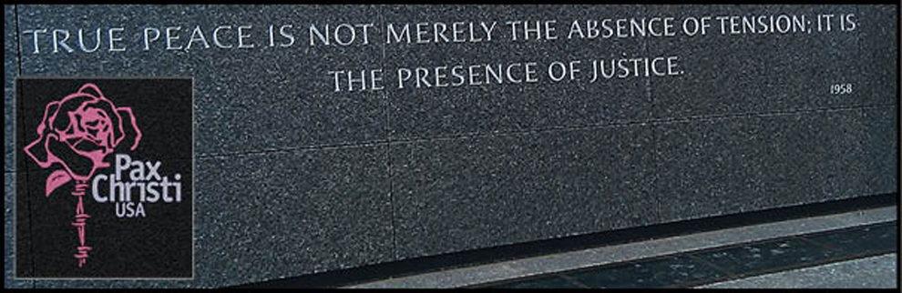

Next Meeting: June 1st, 2019 beginning @ 10:00 a.m. in
St. Jerome Catholic Church: In the Outback Building
Bring your Liturgy of the Hours.
Early Birds: An opportunity to join together in The Holy Mass in the day chapel @ St. Jerome @ 8:15 a.m.
Candidates and Inquirers Formation begins @ 9:00 a.m. in the Outback!
Alba Hernandez, OFS was elected & installed as Galveston-Houston Archdiocesan Council of Catholic Women President on Friday, May 17th, 2019! Our Fraternity in service!
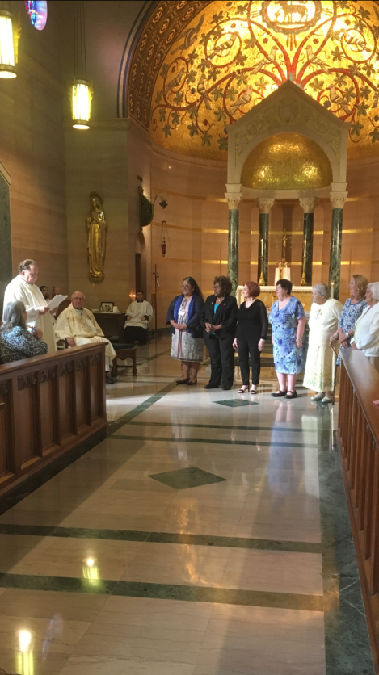

10-12-19 Fiesta Franciscana in San Antonio, TX – 9:00 a.m. – 3:30 p.m.
with Fr. Daniel Horan, OFM
“All God’s Creatures: Rethinking Franciscan Theology of Creation”
Registration $20 plus $15 for the optional lunch.
For more information, contact Stan Whitener, OSF @ (210) 827-5309
See last page of Newsletter for more info.

FOR MORE INFORMATION ABOUT EVENTS & FORMS, PLEASE REFER TO E-MAILS FROM secretary.StMaxSFO@gmail.com

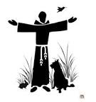

Do not be dismayed by the brokenness of the world. All things break. And all things can be mended. Not with time, as they say, but with intention. So go. Love intentionally, extravagantly, unconditionally. The broken world waits in darkness for the light that is you.
L.R. Knost
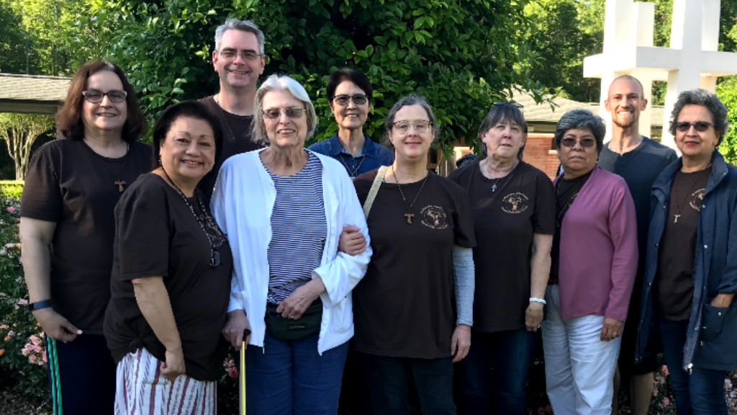
May 2019 The St. Maximilian Kolbe Fraternity of the Secular Franciscan Order
at St. Joan of Arc Regional Retreat
Diocese of Lake Charles Retreat Center, Moss Bluff, Louisiana

Looking forward to October and Fiesta Franciscana.
Daniel Horan, OFM was a keynote speaker at the last “Q”
and was incredible!

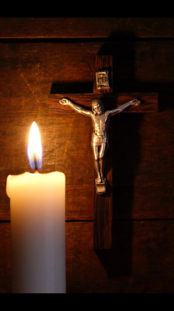

“The Church expects from the Secular Franciscan Order, one and only, a great service in the cause of the Kingdom of God in the world of today. The Church desires that your Order should be a model of organic, structural and charismatic unity on all levels, so as to present itself to the world as “a community of love.” The Church expects from you, Secular Franciscans, a courageous and consistent testimony of Christian and Franciscan life, leaning towards the construction of a more fraternal and gospel world for the realization of the Kingdom of God.”
St. John Paul II – Address to the SFO November 22, 2002

