Secular Franciscan Order June 2020 Newsletter

The Secular Franciscan Order was established by St. Francis of Assisi more than 800 years ago. Our purpose is to bring the Gospel to life where we live and where we work. We look for ways to embrace the Gospel in our lives and try to help others to do likewise.

The Maximilian Kolbe Fraternity emerged out of the Annunciation Fraternity and was canonically established on March 4th, 2001. The first member listed in our registry, Rachel Persicano, made her profession to the Secular Franciscan life May 11th, 1991 under the Annunciation Fraternity minister, Tim Lamb (when he was a Secular Franciscan prior to becoming a Friar). Brother Lamb, OFM recently led our Day of Reflection. Ryan Efaw, OFS

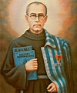

our Gathering
June 6th, 2020

It was so good to be able to meet in person again! It was wonderful to see those that felt safe enough to venture out. Great job for keeping us all social distanced by the configuration of the meeting space. Alan Allen, OFS made sure to include others by making our Gathering available on ZOOM.

Danny Marquer, OFS led us in the candle prayer remembering past, present and future Franciscans.

Dora Freeman, OFS shared a reading from Franciscan Journey Additional Readings – Chapter 18 on obedience and the Holy Spirit. Conclusion – Engaged Spirituality – Joseph Nagle, OFM – pp. 89-90
We were reminded that “we, too, are assured the power of the Holy Spirit from Jesus, and that Spirit will continue to challenge, console, inspire and direct the work of furthering God’s reign on earth through us flawed human beings. We only need recognize the graces given for our times and to respond to them in obedience.” A great discussion followed.

With this being our first “in person” gathering since March 2020, we spent time catching up with how everyone was doing. We shared our thoughts and feelings of the recent Profession of Phyllis Prince, OFS & Eileen “Ike” Colleton, OFS. It was mentioned taking a white and red rose, (signifying the two crowns our Lady offered St. Maximilian) and placing them in front of the statue of Mary to honor Our Blessed Mother was a beautiful expression of our love for the Mother of God. Although we were not able to have the typical celebration afterwards; this Profession, besides the only one in our history during a pandemic, was live streamed! This allowed family and friends in Louisiana, Washington D.C., Arizona, Oregon, all parts of Texas to watch! We are so grateful for St. Jerome Catholic Community and Staff for all they do for our community. There was no Saturday Parish Mass scheduled, yet Fr. Mike Van Cleve, our Spiritual Assistant celebrated a Profession Mass with us, assisted by Deacon Dan O’Dowd. Deacon Pedro set up the equipment and Louis De La Cruz streamed it for us! Of course, none of this would not have been possible if not for our Pastor, Father Dan Scheel, who agreed to our request.

During our Gathering, Dora Freeman, OFS shared a reading from TAU-USA: Spring 2020 edition, pp 11 by Fr. Christopher Panagoplos, T.O.R., CNSA: A Culture of Contempt. Excerpts from the article “Our Rule challenges us as Franciscans to build the Kingdom of God in temporal situations and activities. We do not live in two worlds, nor do we live two lives. We may not accept everything that people develop, nor embrace ideas that oppose the Gospel. Like it or not, we live in one world. And it belongs to God.” We were given an opportunity to discuss the article and share our thoughts.

We then took a short break to stretch our legs.

We celebrated the Rite of Admission for Veronica Rojas, Claire Dwyer & Carla Lewton! It was a joyous occasion to welcome them into our Order!! WELCOME WELCOME!

Mike Freeman, OFS invited us to all join in one voice in reciting The Salutation of the Virtues, pp. 78 in our Ritual.

We ended with the Closing Prayer, pp. 36 of our Ritual.

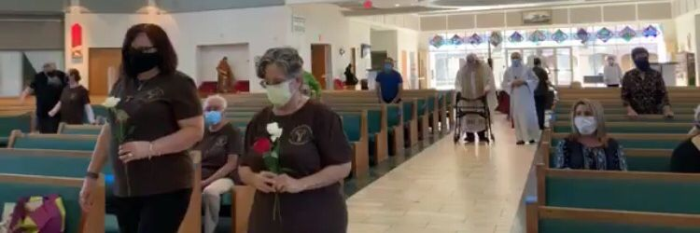

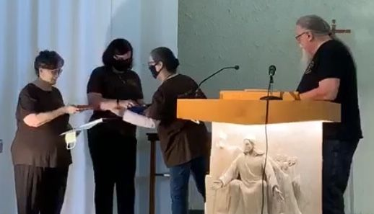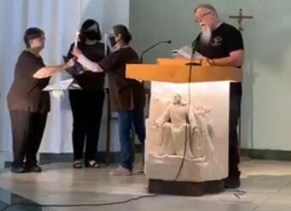

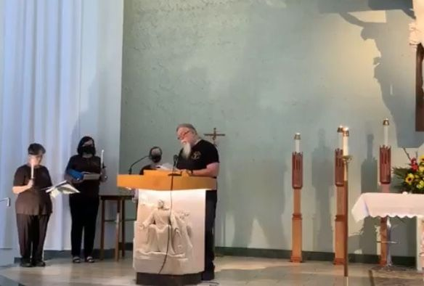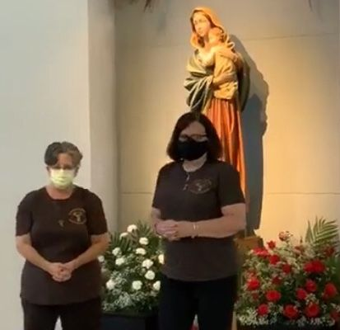
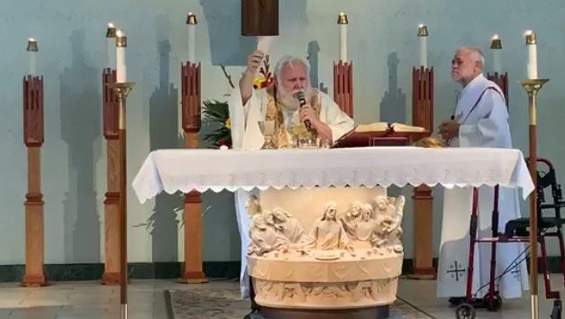

“We have nothing to fear, not even the devil. But one virtue the devil fears most is humility. He is terrified more by humility than deep faith because humility is the virtue that makes us like Jesus. Jesus asked us to learn from Him because, he said, “I am meek and humble of heart.” We should try to learn from Jesus himself rather than relying on books. If we try to learn humility from books we become confused and it seems difficult to imitate the way of humility.” St. Teresa of Calcutta

Greetings Good People
This past month we were so Blessed to be able to gather in person celebrate the Permanent Profession of Eileen and Phyllis, receive the Most Holy Eucharist, and during our regular gathering welcome Carla, Clair and Veronica into our Order as candidates.
Right now the situation with Covid-19 has worsened across most of the country and we in Harris County have again been requested to stay at home so we will gather again in space for our July 4th gathering.
Our Regional Council meeting was cancelled due to issues related to Covid-19; yet we were able to hold our Regional Executive Council meeting in Lake Charles on June 12-13, 2020. At our next gathering I will bring all up to date on what has and is happening.
The St. Joan of Arc Region is hoping for their National Visitation in December If an appropriate location can be found
(Diocese of Baton Rouge has closed facilities, and the St. Charles Retreat Center is already scheduled for a local Church’s annual retreat) So…please pray it all works out.
We will likely have our local elections in February, which really is just around the corner. Please remember, we are all called; and the Lord will qualify those He calls!
From my perspective so much has happened in such a short period of time; yet in the larger picture it may be the culmination of hundreds of years finally coming to the surface. I find assurance that amidst the turmoil our Almighty Father has a plan and He alone can calm the seas….and we are part of this plan. Let us be, (if I can lift a line from Deacon Dan’s homily of 6-25-2020), the lighthouse that shows the way.
Our National J.P.I.C. Animator Carolyn Townes shared with us recently a Special Edition of her J.P.I.C. newsletter and the OFS USA statement on Racism. This is so important I wanted to include parts of it.
She wrote:
Our Catholic social teaching calls us to respect and honor the dignity of every human life, from the womb to natural death. It makes no exclusions on the basis of color or ethnicity and calls out no other distinction to be excluded.
We are called to honor and respect the lives of people we love and people whom we may find it hard to love; people who are like us and people who are different from us.
From the Pastoral Letter Against Racism, Open Wide Our Hearts, by Committee on Cultural Diversity in the Church of the United States Conference of Catholic Bishops:
Racism arises when – either consciously or unconsciously – a person holds that his or her own race or ethnicity is superior, and therefore judges persons of other races or ethnicities as inferior and unworthy of equal regard. When this conviction or attitude leads individuals or groups to exclude, ridicule, mistreat, or unjustly discriminate against persons on the basis of their race or ethnicity, it is sinful. Racist acts are sinful because they violate justice. They reveal a failure to acknowledge the human dignity of the persons offended, to recognize them as the neighbors Christ calls us to love (Mt 22:39).

As Catholic Christians and Franciscans, we owe it to ourselves to do the following in response to racism:
• To identify and eradicate the structures in our societal institutions that perpetuate racism, and replace them with structures that are fair and just, and that value the lives and gifts of every person.
• To pray for an end to racism; indeed, to pray for interracial solidarity, for our laws and our faith practices to reflect our compassion and value for the dignity of every human life; and that we lovers and followers of Jesus and Francis of Assisi, be leaders in bringing about a rightly informed sense of racial equity and justice in our land and in our Church.
• To identify and confront our own unconscious racial biases. After a shared history of hundreds of years in this country, we all have them. They make their way into our lives and culture, often unnoticed. But we can become more just and open by discovering these unconscious biases and replace them with love and engagement. And finally, we need to have safe and meaningful dialogue about those racial biases. We owe it to ourselves and to our brothers and sisters to develop a strong sense of community and fraternity through peaceful conversations. This is truly a conversion moment where dialogue and education are needed.
Our Holy Rule calls us to be “bearers of peace” and we all must bear the burden of peace as we walk this journey towards holiness as brothers and sisters, with open hands and joyful hearts.
Come, Holy Spirit! Lord, make it so!
From: Carolyn Townes, OFS USA J.P.I.C. Animator

Not only is our country experiencing division so is our Church. Like Francis we are called to rebuild the Church. This cannot be brought about by sowing division. Let us remember; we always pray that Our Fathers will be done, not ours! I love this prayer from the late Fr. Mychal Judge O.F.M.
Mychal’s Prayer
Lord, take me where You want me to go;
Let me meet who You want me to meet;
Tell me what You want me to say;
And keep me out of Your way.
Amen
To be able to discern God’s will and act upon it is what we have all been called to do. I too often should have taken a “Franciscan Pause” prior to writing or saying something; getting upset and avoiding social media due to a post which likely had its origin via trolls, etc.
Let us internalize the beautiful words from the song … ”let there be Peace on Earth and let it begin with me”.
Peace
Michael

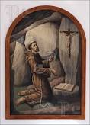 Remain in prayer for:
Healing prayers for Michael Freeman, OFS & his diagnosis of prostate cancer
Continued healing for Dexter, Phyllis Prince’s nephew & Godson
Prayers of healing for Alba Hernandez, OFS
Amy Le & family for continued employment for her husband
Prayers of Thanksgiving for Veronica Rojas’ new job & Covid-19 negative testing results
Healing prayers for Fabiola’s family positive Covid-19 test results
Healing prayers for Ike’s sister, Mo as she is scheduled for a heart ablation procedure 7-20-20

Next VIRTUAL Meeting: July 4th, 2020
ZOOM TIME: 10:00 a.m.
Candidates & Inquirers in Formation: Check your email from your group coordinator for details.

PLEASE continue to Wear A Mask & Wash Your Hands!
Congratulations are in order for Mary Pierson’s 6-1-2020 appointment as Executive Director of the Emmaus Spirituality Center. In these difficult times of a pandemic & uncertain financial future, please pray for the resources needed to keep things running smoothly & efficiently.

Alba ordered some F.U.N. Manuals (For Up to Now – Foundational Topics for Initial Formation). They do not come with a binder. Purchase price is $13/ea.

$$$ Continue to save money for our contribution bag!
Cash or checks made payable to: St. Maximilian Kolbe Fraternity.

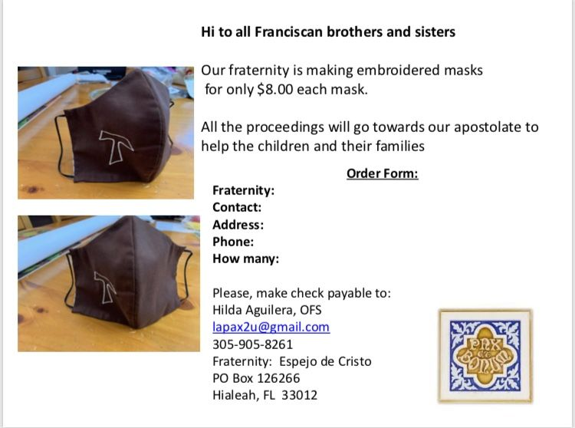

Every Day for PRAYER!

20th Quinquennial Congress 2021
Phoenix, AZ
August 18-22, 2021
THEME: Jubilee
“To celebrate and renew our Franciscan calling in the spirit of conversion”
Early Bird Registration: 8-18-20 through 12-31-20
$350 pays for meals, packet & conference expenses
Hotel Reservation Sheraton Phoenix Downtown: $89 plus tax/night (1-4 persons)
2 Queen beds or 1 King
Secularfranciscanusa.org or
www.quinquennialcongress.org

For more info, see emails from secretary.StMaxSFO@gmail.com

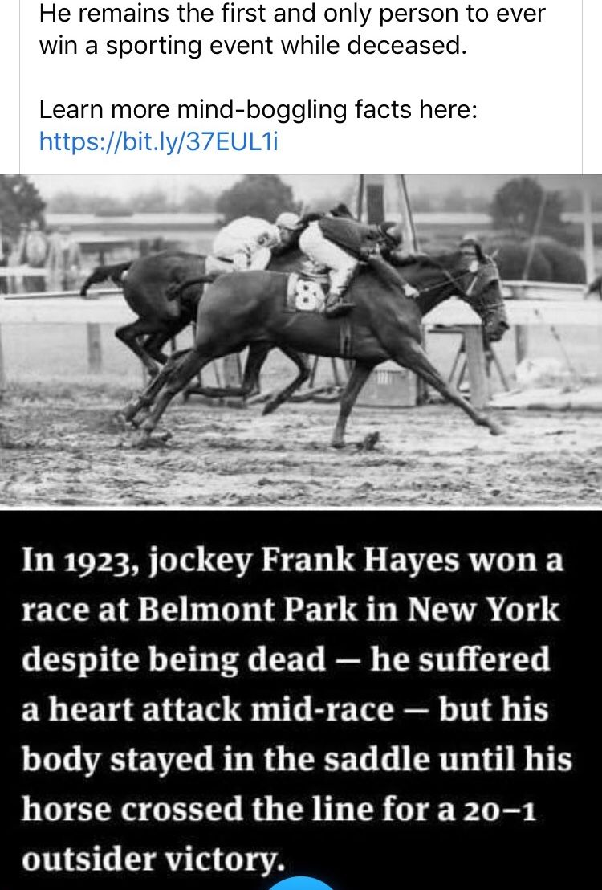
Think God can’t use you? Think again!! He makes ALL possible!
I Can See Clearly Now

“You are my hiding place; you will protect me from trouble and surround me with songs of deliverance.”
Psalm 32:7 (NIV)

Our African Safari had meandered through the bush when a flat tire stranded us.

“I need everyone’s help,” said the guide.

We dug sand from around the wheel and replaced the tire.

I wiped my forehead and looked around. The glaring sun made it hard to see anything. I put on sunglasses and noticed six lions lying in the shade just twenty feet away.

I called, too casually. “We have company.”

The guide looked up as a lioness stood and sauntered toward me.

“Into the vehicle,” the guide commanded. “As long as you’re inside, animals can’t tell you apart from the jeep.”

We all jumped in, but my shoulder hung perilously just outside the roll bar.

“She’s just curious,” the guide reassured us.

What if this is a smart lion and knows the difference between metal and my delicious tender red meat?

All of a sudden, the lioness turned around and plopped down under the tree.

As we made our way out of the bush, I pondered. What if I hadn’t put on my sunglasses to see the danger? How might it have gone?

Prayer is often like a pair of UV-reducing shades. I can see things much clearer after spending time with God. He is always my protector and deliverer. Satan may be like a roaring lion, seeking to devour us. But with Jesus as our strong tower, nothing can touch us.

Heavenly Father, I can’t go it alone in the jungles of this world. Help me discern the enemy watching – waiting. Cause me to run to you for protection and wear the full armor of God. Amen!

Author: Tez Brooks
Guideposts - All God’s Creatures
Daily Devotions for Animal Lovers
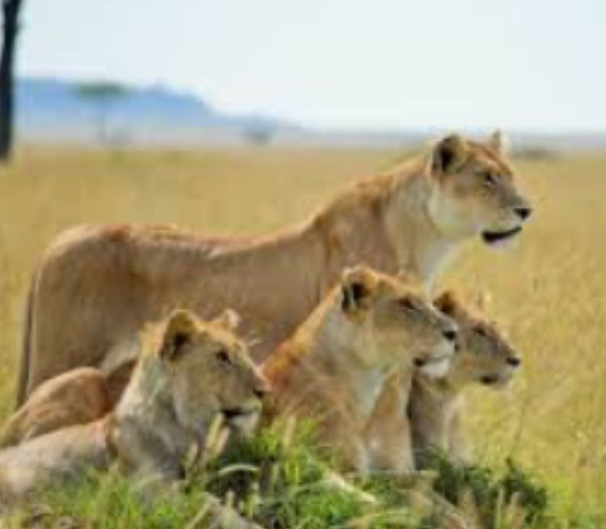
“Those silly humans think we can’t tell the difference between them and the vehicle? That’s a good one, hun!”

FROM: Denice Foose, Director – Catholic Chaplain Corps:
So proud of my colleague and mentor, Karen Parsons. She has a couple of books out & 1 new one on its way. Check her out on Amazon. Great inspiring reads!
The Catholic Chaplain Corps honors our friend and colleague:
Karen Parsons - Galveston Seaman Center, Port Chaplain, Archdiocese of Galveston Houston
"Unique" and "distinguished" accurately describe Karen Parsons, in her 35-year career in maritime ministry. The first Catholic laywoman (in the world!) to be appointed as a port chaplain, Karen went on to make important contributions to her professional field as an international speaker and author giving voice to seafarers who often have no voice. Her one-on-one ministry and public advocacy has garnered recognition from national and international groups: the United States Coast Guard (Meritorious Service Award and Public Service Award), plus the Vatican (two Papal awards). And most recently, Karen received the Distinguished Service Award from the North American Maritime Ministry Association.
Congratulations Karen!
