Secular Franciscan Order June 2021 Newsletter

The Secular Franciscan Order was established by St. Francis of Assisi more than 800 years ago. Our purpose is to bring the Gospel to life where we live and where we work. We look for ways to embrace the Gospel in our lives and try to help others to do likewise.

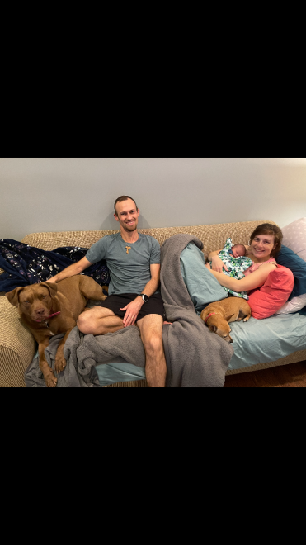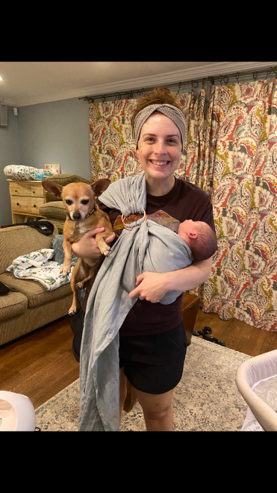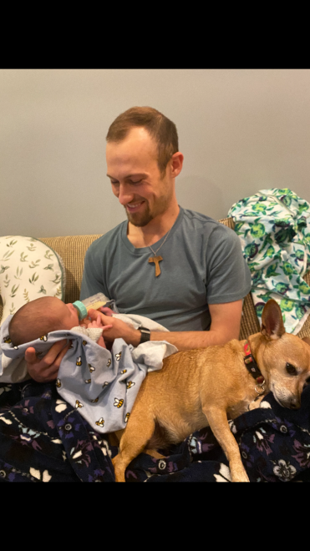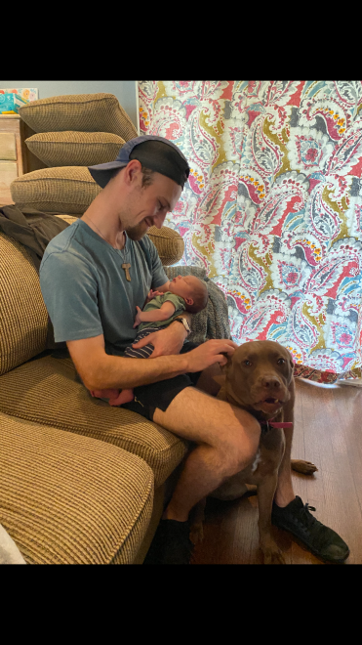

1.
Our Gathering

We began our Gathering traditionally with the Ritual of the SFO, page 35.

We welcomed Kathryne “Kat” Leiser as a visitor. We hope she enjoyed her visit and hurries back next month.

Phyllis Prince led us in the Candle Prayer as we remembered all past, present (including those who can no longer participate due to health) and future members of our Franciscan family.

Alan announced that we will need someone to consider taking the position of our local YouFra Animator. If interested, please let Alan or Fabiola know. Please prayerfully consider God’s call to fill this position.

Fabiola is very enthusiastic about Café Catholica which will be held every Monday in the month of July at the Charismatic Center, targeting the age group 18-39. This year’s theme is: Courageous Love. There will be Mass at 6:00 p.m. followed by a guest speaker @ 7:15p.m., then a snack, Confession & a tailgate gathering @ 8:15p.m. In the past, our Fraternity has had a table in the Vendor area. It is a great opportunity to let young adults know about our ministry as Secular Franciscans. Fabiola is requesting our Fraternity volunteer to attend and be present at our table, responding to any questions & passing out literature. A sign-up sheet will be passed around. July 5th, Mark & Katie Hartfiel; 12th, Chika Anyanwu; 19th, Colin Nykaza; & 26th, Cardinal DiNardo. Guest speakers underlined for the dates listed. If interested, contact Fabiola. Carpooling is a possibility!

Cindy Borgerding read the parable of the Good Samaritan as a Lectio Divina. We were given time to share our understanding of the parable and insights we gleaned. We were asked to share any of the Articles from Gospel to Life that we felt were appropriate to this parable. It was a wonderful discussion and helped develop a better understanding of Chapter 2 of Fratelli Tutti.

Danny Marquer, in his wit & wisdom shared a quote: “It is good for Good for Nothings to do good for nothing!”

We all participated in the reading of The Litany of St. Anthony of Padua, led by Alan Allen.

We ended traditionally with the Ritual of the SFO page 36.

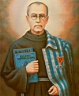
2021 is the 80th anniversary of the self-sacrifice of St. Maximilian Kolbe. In 1941, he saved the life of
Franciszek Gajowniczek in Auschwitz, the Nazi concentration camp.
2.
Greetings Sisters and Brothers

“BE MORE!” This was the first thing Mario Enzler, the Dean of the Cameron School of Business at St. Thomas University, said to us at a presentation he gave back at the end of last year.

“BE MORE!” Mario told us the story of how St. Pope John Paul II challenged him with this statement while he was a Swiss Guard. He then elaborated on how St. Pope John Paul II always gently exhorted the people he met to “be more”. Be more authentic, be more of a Christian, be more of a light in the world.

I have been thinking about this quote a lot over the last couple of months. How can we “be more” in the world? Especially in a world that is so upside down these days it seems like an exhortation that is more important and more challenging than ever. As we were going through our formation topic at our June meeting this idea of “be more” seemed to fit well. How did the Samaritan “be more” in the story? He did what was not expected. He took care of a Jew and even got others, the innkeeper, to help him. He did not ask to be recognized for what he did. He did not ask to be repaid. In a situation where he could have just walked by, he instead chose to “be more”. He did for his “neighbor”, the wounded man, even when it was not expected of him since he was a “foreigner” to the Jews. He showed the original listeners of the story, and us, that we should see everyone as our neighbor. We also talked a lot during our gathering about the other characters in the story. Who else in the story decided to “be more”? How did they do this? These are questions I am still wrestling with and I am sure I will be for a while longer yet. I know that I’m each of the different characters at different times and in different situations. I’m not proud of this fact but it is true. Thinking about these characters and this quote, “BE MORE!” I am challenged. I am challenged to see the characters in a different light. I am challenged to think about how, as each one of these characters, I could be different. I know that even as the answers each of us finds to these questions will likely be different, ultimately, we just need to take the quotes off and BE MORE.

“81. Jesus asks us to be present to those in need of help, regardless of whether or not they belong to our social group. In this case, the Samaritan became a neighbor to the wounded Judean. By approaching and making himself present, he crossed all cultural and historical barriers. Jesus concludes the parable by saying: ‘Go and do likewise.’ (Lk 10:37)” Fratelli Tutti, Pope Francis

Blessings,
Alan

3.

Next Meeting: July 3rd, 2021
10:00 a.m.IN PERSON ONLY
Candidates & Inquirers in Formation: 9:00 a.m. in the Outback
Connie will have coffee available. Feel free to bring a snack to share.
Our Gathering will be IN PERSON
To our sweet Joan Horr; Rest in Peace! Keep her husband, Deacon Louis & family lifted in prayer during this time of grief and healing. You’ll be missed!
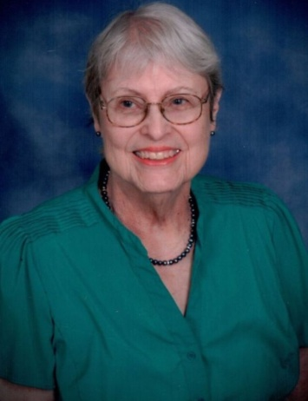

$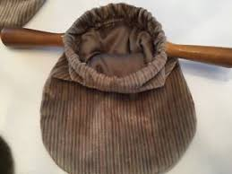$$ Continue to save money for our contribution bag! Bring cash or checks.
Checks made payable to: St. Maximilian Kolbe Fraternity.
A Spanish version of the TAU-USA is now available and being mailed to Spanish speaking members upon request. Email your name, address, fraternity name & region name to:
Cindy Wesley OFS, cw93444@gmail.com Or mail request to:
Cindy Wesley OFS
846 Calimex Place
Nipomo, CA 93444
4.

Psalm 142 “I cry with my voice to the Lord, with my voice I make supplication to the Lord, I pour out my complaint before him, I tell my trouble before him. When my spirit is faint, you know my way! In the path where I walk they have hidden a trap for me. I look to the right and watch, but there is none who takes notice of me; no refuge remains to me, no man cares for me. I cry to you, O Lord; I say, You are my refuge, my portion in the land of the living. Give heed to my cry; for I am brought very low! Deliver me from my persecutors; for they are too strong for me! Bring me out of prison, that I may give thanks to your name! The righteous will surround me; for you will deal bountifully with me.”
Does anyone know why this Psalm is significant & special to Franciscans?

Every Day for PRAYER!
Café Catholica
Catholic Charismatic Center
1949 Cullen Blvd. Houston, TX 77023
Monday nights in July
6pm Mass / 7:15pm Talk / 8:15pm Snacks & Reconciliation
Greater than a Mother’s Love Retreat
August 20-22, 2021
Cedarbrake Retreat Center
Temple, Texas
Diocese of Austin
cedarbrake@austindiocese.org
There are LOTS of ways to become involved.
Reference emails from secretary.StMaxSFO@gmail.com and emails from
Alan @ caallen70@gmail.com for specifics!

August 2021 Meeting will be 8-7-2021 in the
Outback @ St. Jerome Catholic Church

5.
Beneath the Ripples

“Now faith is confidence in what we hope for and assurance about what we do not see. This is what the ancients were commended for. By faith we understand that the universe was formed at God’s command, so that what is seen was not made out of what was visible.”
Hebrews 11:1-3 (NIV)

Today, my family and I went for a hike to a beautiful little pond that’s filled with fish. To get there, we followed a trail through woods that are home to many animals and creatures. I’ve seen photos other people have taken from this same trail and know it’s a rich habitat with everything from birds to foxes, raccoons, deer, and dragonflies. The thing is, on this particular afternoon, I couldn’t seem to spot any of them! When we got to the lake, the same comical pattern continued. Everyone else in my family saw fish jumping, but not me.

Then as I watched the still waters, I heard a splash and turned to see if I could spot the fish. I was too late to catch it before the fish dived underwater, but I did see something else that was even more interesting – rings of widening ripples bending the flat surface of the water, ripples that extended far beyond the place that fish had jumped.

The fact is, there is a diverse ecosystem that exists beneath, above, and beyond those waters. I don’t need to see it to know it exists or to recognize my own part in this intricate design. As I watched those beautiful ripples, I was reminded of God’s work in and through me. I, like that fish, create ripples from my own life. Sometimes I can’t see what God is up to. Maybe I can hear the sound; sometimes other people notice and tell me what they’ve seen. But I don’t always need to see to trust His ways are good. The ripples of redemption are ever spreading toward shores of grace whenever I simply turn to Him.

I alone cannot change the world, but I can cast a stone
Across waters to create many ripples. –Mother Teresa

Author: Ashley Clark
All God’s Creatures May/June 2021
Daily Devotions for Animal Lovers
A Guidepost Publication

6.
Healing prayers for Michael Freeman & his diagnosis of prostate cancer

Pray for the repose of the soul of Joan Horr who headed to Heaven on 6-23-21. Pray for her husband and family as they transition into a new earthly life without her.

Continued prayers for Cindy Borgerding’s sister, Debbie Anderson who was involved in a terrible car accident, sustaining sever injuries. She has a long painful road to recovery.

Claire Dwyer: pray for her daughter Shannon, suffering from anxiety & depression.

Pray for continued success for the ministry of YouFra.

Praise God for beautiful baby Lucca Efaw! Congratulations to Ryan & Caitlyn Efaw!

Pray for all Priests and Seminarians throughout the world.

Fabiola requests healing prayers for her niece in Bolivia: Florencia who is 16 yrs old. She is a diabetic & has fever.

Continue to pray for Mary Pierson & family as they work through their grief.

Pray for Shelley Barger & GG who are both using scooters, unable to walk. Shelley will be undergoing scans at the hospital. Pray outcome will be a favorable one.

Pray for Carla Lewton’s mother Barbara who has been steadily declining. Pray family will find a wonderful healthcare facility that will be agreeable to Carla, her two brothers & Barbara.

Pray for our new Council, for the Holy Spirit to guide them & give them the wisdom they’ll need to fulfill their elected positions with a true Franciscan Spirit.

Remember to email Ike ecolleton@comcast.net for prayer requests & updates to be included in Newsletter

Make sure you make room in The Rule for THE RULER!

7.

