Secular Franciscan Order May 2020 Newsletter

The Secular Franciscan Order was established by St. Francis of Assisi more than 800 years ago. Our purpose is to bring the Gospel to life where we live and where we work. We look for ways to embrace the Gospel in our lives and try to help others to do likewise.

Most High and Glorious God
Bring light to the darkness of my heart
Give me right Faith, certain hope and perfect charity
Lord give me insight & Wisdom
So I might always discern
Thy Holy and true will

our Gathering
May 2nd, 2020
Our second ZOOM Gathering, and one in which we celebrate a Marian month.
As we gathered virtually we prayed together the Opening prayer from our Ritual (pg. 35).

Dora read an excerpt from GATHERING SHARDS by Murray Bodo, OFM. It can be found in the Afterword to this beautiful book in which, as he was gathering together the many shards or pieces of his life he wrote:
I was a Franciscan many years before I became a real Franciscan….all is the mercy of God….I had ‘worked’ at becoming a holy friar for a long time before I realized that I was already holy. That holiness happened…..when…the mercy of God flowed into me with the good water of Baptism……Ours is only to respond to God’s action within us .Pg. 371-372.

When we make our Permanent Profession it is celebrated during the Mass due to it being a public and ecclesial act, a “visible sign of the Church, the Community of Love (preface 3.31).

Let us pray we can all come together in June as Eileen and Phyllis make their Permanent Profession! Afterwards during our regular gathering we will celebrate the Rite of Admission for Carla, Clair and Veronica!

To have a true devotion to Christ, we must have a devotion to Mary.

Rule 9 / Humble Service – Like Mary we must be open to His call, discerning what it is ours to do. By saying YES, we accept consequences & opportunities to go deeper. Devotion to the Blessed Mother has always been a hallmark of our Franciscan Charism. When we allow the Holy Spirit in, we are given all that we need. As Franciscans we are called to daily conversion, going from Gospel to Life, Life to Gospel. Our lifestyles, ministries, and apostolic activities should reflect this. We are Franciscans 24/7.

June 29-August 15, St. Francis fasted in honor of Mary. Perhaps we too, can honor our Blessed Mother by increasing our fasting and prayer during this time.

We are all mothers, pregnant with Jesus. As Seculars we are to bring Christ into the world. Every time we do God’s Will, we participate in birthing Christ into our sphere.

- We all prayed the Litany to Mary, Mother of Life prayer.
- We continued and read Article 9 of Our Rule on Mary the Protectress of the Order and discussed the following questions:
- What qualities of Mary are attractive to you?
- What is Mary’s role in our lives & in the life of the Church?
- What is the goal of devotion to Mary? How do you discern whether your devotion to Mary supports your Franciscan Life?
- What example does Mary set for us as Secular Franciscans?
- We continued with discussion on Mary, Mother of Jesus. (SFO Constitutions: Article 16. 1,.2)
It reads:
Mary, Mother of Jesus, is the model of listening to the Word and of faithfulness to vocation; we. Like Francis, see all the gospel virtues realized in her (from Salutation of the Blessed Virgin Mary). ……….Secular Franciscans and their fraternities should seek to live the experience of Francis, who made the Virgin the guide of his activity”.
- We discussed page 192 from The Franciscan Journey book. “The words of the SFO Rule do not speak of any particular devotion by which we show love for Mary. Instead it says, quite simply: “The Secular Franciscans should express their ardent love for her by imitating her complete self-giving and by praying earnestly and confidently” (SFO Rule #9).

A beautiful discussion followed on how each member was creatively sharing during this quarantine time. When we make our profession or a complete self-giving, it requires that we embrace the journey of conversion. We do what Mary did, “Whatever He (Christ) tells us to do”.

Each of us then had to opportunity to ask for prayer for our personal intentions.
As we continue through this Easter season and approach Pentecost let us,
“With her, like the disciples at Pentecost, they should welcome the Spirit to create a community of love”. (GC Article 16)

We closed our virtual gathering with the closing prayer, page 36 in The Ritual.

Prayerful Ponderings…..
I find it fascinating, having the peace of Christ, yet feeling sad at the same time. A mystical dichotomy for sure! Knowing we are going to become all God intends for us when we see Him face to face in Eternal Glory is mind boggling. Life here can be so precious but absolute joy is to be with The Father. I’ve been applying this knowing to making better choices in my own life; small & big things, learning to choose rightly, understanding how to discern between good and best, sort of a delayed gratification. Experiencing death, loss, grief so much lately changes one’s perspective, allows inner growth & a desire and ability to let go of people and things while maintaining that peace that is beyond understanding. It’s a “God Thing” for sure. I pray for all to truly KNOW this peace. It’s a life long journey, coming to know Christ & embrace who we are in Him. I love you! Ike!

Greetings Sisters and Brothers

As I reflect on these times, and again thinking about the Broken Shards in my own life; I do truly see how, by the grace of God all things come together in Gods time. We know that God makes all things new, and by our Baptisms we are called and freed. So many things that have been taken for granted are now seen in new ways. Many writers have commented on this past Sunday’s reading of why the apostles were looking up to the sky…..Christ is here!
This past Sunday was a beautiful day in our parish, and I am sure others parishes have also been celebrating and receiving those into the Church who have been waiting since the stay at home orders wiped out the Easter Vigil.
We know how we felt when we had to go two months without receiving the Holy Eucharistic…..the joy that was reflected on these people finally staying through the whole Mass and getting to receive the Blessed Sacrament was incredible! Thank You, Jesus.

Our virtual gatherings on Zoom have allowed us, for the most part, to come together. It is nothing I would have ever imagined, but good has come from it. Since we started I have experienced a 2 day Zoom conference with the National Fraternity and Regional JPIC Animators which went smoothly; a teleconference with my Dr. which caused me to chuckle as she was unaware she was being seen and heard telling the nurse how it makes her look like she has a double chin, and an ARD/IEP meeting with a school district trying to resolve several areas of concern.

We have learned that the full gatherings are difficult yet the smaller formation groups seem to work well. This has opened up another way for us to stay in contact during the month (especially if Mytiburger is not in your neighborhood)!

Our sisters Eileen and Phyllis will finally be able to celebrate their Permanent Profession. Please, if you feel safe come join us for this at the 8:15 a.m. Mass on our regular gathering day, June 6, 2020. More details to come!

Precautions are being taken to insure everyone’s safety. We will also transition back into our in person gatherings, but not in the Outback House as we want to be able to maintain appropriate distance. We will come together in the Fr.Raye Center, across the plaza on the eastside of the main sanctuary.
During our gathering we will have another celebration, the Rite of Admission into the Secular Franciscan Order for Carla, Clair, and Veronica!

Peace
Michael

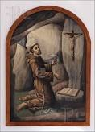 Remain in prayer for:
Healing prayers for Michael Freeman, OFS & his diagnosis of prostate cancer
Continued healing for Dexter, Phyllis Prince’s nephew & Godson
Prayers of healing for Alba Hernandez, OFS
Prayers for the repose of Sandra Flake, Joan Horr’s sister who was taken by Sister Death
Prayers of healing for Fr. Joseph, OFM (recovering from COVID-19 in Louisiana)
Prayers of healing for Cindy Borgerding’s brother in law, Dave’s kidney transplant and for Dave’s brother who had a stroke. He donated the kidney for Dave.
Prayers of Thanksgiving for Ike’s niece, Natalie Johns who had brain surgery on 5-14-2020 for CSF leak. She is recovering nicely!

Next Meeting: June 6th, 2020
TIME: 10:00 a.m.
In the St. Jerome Fr. Raye Center
MASS with The Rite of Profession of Phyllis Prince & Eileen Ike Colleton into the Secular Franciscan Order is now set for
June 6th, 2020 to be held at the 8:15 a.m. Mass
St. Jerome Catholic Church Main Sanctuary
When we come together we will also be celebrating the Rite of Admission into the Secular Franciscan Order for Carla and Clare!

PLEASE Wear Your Mask!
T-Shirts are available in many different colors. If you’re interested in purchasing one, please contact Alba. They are $20/ea. Alba ordered some F.U.N. Manuals (For Up to Now – Foundational Topics for Initial Formation). They do not come with a binder. Purchase price is $13/ea.

$$$ Bring in all that money you’ve been saving for our contribution bag!
Cash or checks made payable to: St. Maximilian Kolbe Fraternity.

Every Day for PRAYER!

Quinquennial Congress 2021
Phoenix, AZ
August 18-22, 2021
THEME: Jubilee
An opportunity to celebrate and renew our Franciscan calling in the spirit of conversion
Early Bird Registration planned for November 2020
$350 pays for meals, packet & conference expenses
Hotel Reservation: $105/night
www.quinquennialcongress.org

For more info, see emails from secretary.StMaxSFO@gmail.com

“Human beings may separate things into as many piles as we wish – separating spirit from flesh, sacred from secular, church from world. But we should not be surprised when God does not recognize the distinctions we make between the two. Earth is so thick with divine possibility that it is a wonder we can walk anywhere without cracking our shins on altars.”
Barbara Brown Taylor, An Altar in the World

Comforted to Comfort

“Whoever refreshes others will be refreshed.” Proverbs 11:25 (NIV)

I watched the YouTube video in awe. There sat a man playing Debussy’s Clair de Lune in the middle of a wooded area and his only audience was an eighty-year-old female elephant named Ampan, who resides at ElephantsWorld, a sanctuary for elderly, injured, and handicapped former logging and trekking elephants in Thailand.

Paul Barton, a retired classical pianist, plays his piano throughout the sanctuary, giving the elephants their own private concerts. The first time he played, a blind elephant, which was often in pain, stopped eating and stood still, listening to the sounds of Beethoven. “I like to think maybe the soothing music gave him some comfort in the darkness,” Paul said.

Paul’s serenades allow these animals to enjoy the beauty and peace of the world and to ease their weariness.

Watching the videos made me realize that whether we are experiencing the discomfort of growing older or dealing with pressures, pains, and problems of life, we, too, long for peaceful times that comfort our weariness. And as the apostle Paul reminds us, God never fails to bring us the consolation we need. As a result, we are able to comfort others, whether humans or animals, so they can experience God’s love and concern for them.

I can’t play Debussy for elephants in Thailand, but I can bring relief in other ways. It is an amazing privilege to receive comfort. It is an even greater privilege to use the comfort we receive to bring beauty and peace into the world of people and animals who might desperately need it.

“The Father of compassion…comforts us in all our troubles, so that we can comfort those in anty trouble with the comfort we ourselves receive from God.” 2 Corinthians 1:3-4 (NIV)

Guideposts - All God’s Creatures
Daily Devotions for Animal Lovers

Priest/Seafarers/PrisonMinistry/Teach/ComputerTech/AnimalRescue/Mom/Dad/Nursing/Caregiving/PrayerWarriors/Accountants/Decorator/Waitress/Student
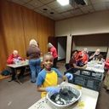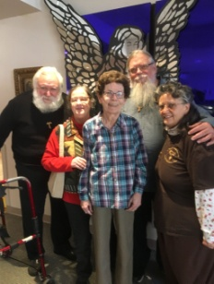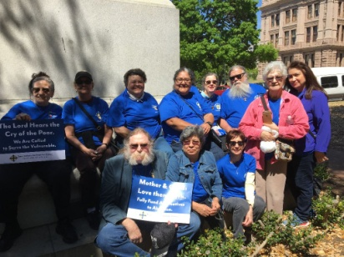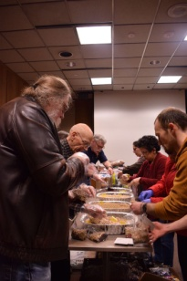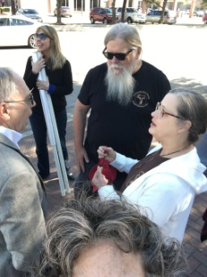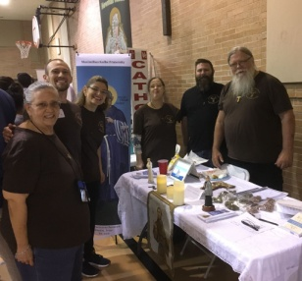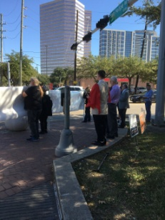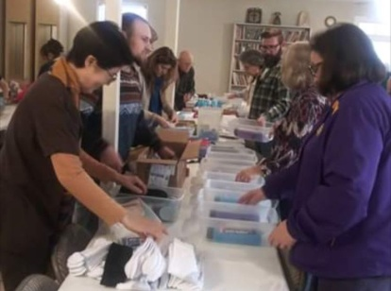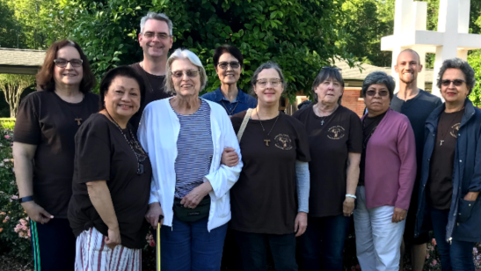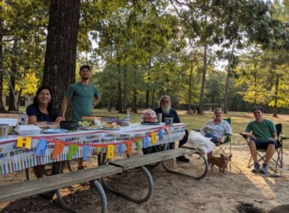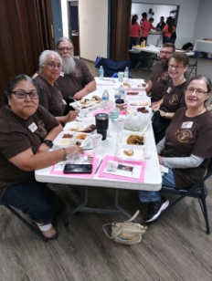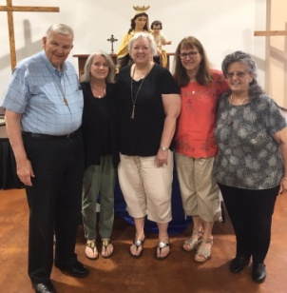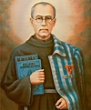
Doctor/Lover/Worshiper/Musician/Vocalist/Cantor/Listenor/Counselor/Evangelist/Ponderer/Writer/Construction/Chef/Coach/Farmer/Seamstress/SAINTS!!!

