Secular Franciscan Order January 2019 Newsletter

The Secular Franciscan Order was established by St. Francis of Assisi more than 800 years ago. Our purpose is to bring the Gospel to life where we live and where we work. We look for ways to embrace the Gospel in our lives and try to help others to do likewise.

2019 is the 41st year of our current Rule approved in 1978!

Our Gathering
January 5th, 2019 St. Maximilian Kolbe Fraternity Meeting was held in The Outback at St. Jerome Catholic Church. Our meeting began as usual with our Ritual Book of prayers. In continuing with our study of the Rule, Dora read a brief passage from Thomas of Celano’s: “The Remembrance of The Desire of a Soul”. St. Francis called The Rule our Book of Life, the hope of salvation, the marrow of the Gospel, the way of perfection, the Key of Paradise, the pact of an eternal covenant. He taught that we should keep it always before our eyes as a reminder of the life we should lead.

Alan then gave an introduction of Article no.9 from the Rule concerning the Virgin Mary as Protectress of our Order. We strive to imitate her complete self-giving. Discussion followed. We were pleased to have visitors present discerning our way of life: Veronica on her second visit & Carla, her first. Welcome, friends!

Our February meeting will be one of the most special events in the life of our fraternity: PROFESSION! After many years of discernment and growth, we will receive Alan Allen, Danny & Maria Marquer, Cindy Borgerding and Fabiola Cespedes-Pena as professed members. What a blessing to our Fraternity, our Order, our Church. Our entire Fraternity will process in at the beginning of Mass as a sign of unity & solidarity.

Hold back nothing of yourselves for yourselves
so that He Who gives Himself totally to you
may receive you totally.
St. Francis of Assisi

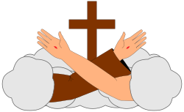
Greetings good People

This month there are so many things I had planned to talk about yet when I sat down to do it, I kept going back to the letter recently sent out from OSF-U.S.A. I have copied most of it below and hi-lighted those areas that jump out at me & added to in italics.
HERE IT IS:

The NEC is happy to announce that this was accomplished at our December 13-16, 2018 meeting in St. Louis, MO. During this meeting we prayerfully considered the needs of the national family, as well as the feedback from the NAFRA Geo Groups at Chapter, and the decision became clear to us. While in past years NAFRA has set as many as six priorities, this year we chose to narrow our focus to one---Fraternity Life. Note that concentrating on fostering vibrant fraternity life does not imply that previous priorities will be ignored or neglected. Formation, JPIC, Communications, and Spiritual Assistance will all play an important role in strengthening our local fraternities.

Do you remember when you professed? You said this is what you wanted, and you said it three times!

The decision to choose Fraternity Life was confirmed for us in a wonderful way! A few weeks after we chose this priority, we received a Christmas letter from our General Minister. In this letter Tibor Kauser encouraged us to repeat our “yes” unconditionally – saying yes to God, yes to our vocation and yes to our neighbor. He then repeated three times “…this will give new life to our fraternities, too!” To help all of us achieve this priority we decided to highlight three aspects of fraternity life:

National Priority 2019-2021
Fraternity Life
1. Deepening our Franciscan Vocation
2. Growing in Fraternal Communion
3. Cultivating Universal Kinship

Meanwhile, let us begin by reflecting on the spiritual reality and purpose of our fraternities. We’re so used to participating in various groups, both within and outside the Church, that it’s easy to treat our fraternity as just another group, rather than an integral part of our vocation. Let’s look at our foundational documents. How do they portray fraternity?
Our General Constitutions state:

Art. 28.1. The fraternity of the OFS finds its origin in the inspiration of Saint Francis of Assisi to whom the Most High revealed the essential gospel quality of life in fraternal communion (See Constitutions 3.3 (below); Testament 14).

Art. 3.3. The vocation to the OFS is a vocation to live the Gospel in fraternal communion. For this purpose, the members of the OFS gather in ecclesial communities which are called fraternities.

Art. 100.3. Fidelity to their own charism, Franciscan and secular, and the witness of building fraternity sincerely and openly are their principal services to the Church, which is the community of love. They should be recognized in it by their "being", from which their mission springs.

Points to ponder:
- The fraternity is not an afterthought. It originated with St. Francis, and its essential gospel quality was revealed to Francis by God Himself.
- We don’t just “live the Gospel.” We live it “in fraternal communion.” Fraternal communion is thus defined as a constitutive element of our vocation. We have a specific way of being in the world, and a specific way of being together…in fraternal communion.
- The Constitutions tie building fraternity to our Franciscan mission of ‘rebuilding’ the Church. In fact, they term it one of the principal services we as an Order do for the Church. Recall that during our profession we promised to spend our efforts doing this very thing.

“The local fraternity is a visible sign of the Church, a community of faith and love. Together with all the members you now pledge yourselves to spend your efforts to make the fraternity a genuine ecclesial assembly and a living Franciscan community. Rite of Profession, Ritual of the Secular Franciscan Order].

Read below and honestly ask yourself if you are fulfilling your promise

If we fail to take this seriously, if we work half-heartedly, if we rarely show up at fraternity gatherings, we are failing our brothers and sisters, we are failing to live our profession, and we are failing the Church.
Are you?

- Thomas of Celano tells us that Francis and his brothers rejoiced when others were added to their company.
“Immediately four other good and sound men were added to them as followers of the holy man of God. …At that time Saint Francis and his brothers felt great gladness and unique joy whenever one of the faithful, led by the Spirit of God, came and accepted the habit of holy religion whoever the person might be: rich or poor, noble or insignificant, wise or simple, cleric or illiterate, a layman of the Christian people. This was a great wonder to those of the world and an example of humility, challenging them to the way of a more reformed life and to penance for sins.” (1 Celano 31

“Come to [Jesus], a living stone, rejected by men yet chosen and precious in God’s sight, and like living stones, let yourselves be built into a spiritual house….” 1 Peter 2:4-5a
To be a Franciscan our message of the Gospel is countercultural. We see the dignity of God in all of Creation. Each of us as individual living stones can be rebuilt into this wonderful spiritual house which can than rebuild our Church …….. Are we willing to allow the Holy Spirit to begin this first within ourselves? Let us pray the prayer Fr. Mychal Judge OFM gave us:
Lord, take me where You want me to go,
let me meet who You want me to meet,
tell me what You want me to say,
and keep me out of Your way.

This Saturday we are Blessed that five of our brothers and sisters are professing. Let us all be there at the Saturday morning Mass at 8:15 to joyfully celebrate as Alan, Fabiola, Cindy, Maria, and Danny make their permanent profession.
Peace
michael

Next Meeting: February 2nd, 2019 beginning @ 8:15 a.m. in
St. Jerome MAIN SANCTUARY

***REMINDER: The Profession Ceremony for Alan Allen, Danny & Maria Marquer, Cindy Borgerding & Fabiola Cespedes will be at the 8:15 a.m. Mass in the main Sanctuary @ St. Jerome!*** To prepare for this special occasion, please read pages 18-26 in the Ritual Book (the Rite of Profession). Also, it would be nice to bring food or other festivities for the gathering afterwards.

Caritas Day 2019: Saturday, March 16th, downtown Houston. Includes Mass, breakfast. TIME: 9am-noon

Advocacy Day 2019: Tuesday, March 26th in Austin, TX. Contact Alba Hernandez for more information.

Regional SFO Retreat: Friday May 3rd – Sunday May 5th. Moss Point, LA (registration form below)

FOR MORE INFORMATION ABOUT EVENTS, PLEASE REFER TO E-MAILS FROM secretary.StMaxSFO@gmail.com

REGISTRATION FORM ST. JOAN OF ARC RETREAT 2019
Secular Franciscan Order
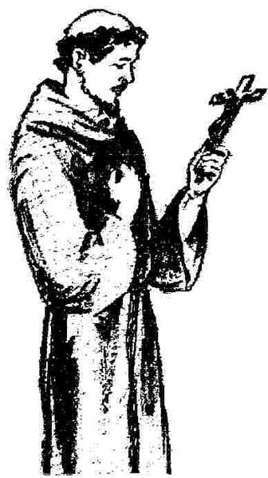
Fr. Jacob-Matthew Smith, OFM
May 3-5, 2019
St. Charles Retreat Center
Moss Point LA.
2151 Sam Houston Jones Parkway - Lake Charles, La. 70611
Important Instructions: Please TYPE or PRINT all information clearly.
- Only one participant per registration form.
- Payment must accompany this form.
- Make your check for registration payable to: St. Joan of Arc Region
- DEADLINE FOR FEES: APRIL 27, 2019 – SORRY, NO REFUNDS AFTER APRIL 27, 2019.
- Mail this form with payment to: Patsy T. Burgess, OFS, Retreat; 2308 Jerlyn Drive; Denham Springs LA 70726; pthibodeauxofs@gmail.com; 225-907-8248.
- Sorry, we cannot accommodate walk-ins.
- Please do not let finances prevent you from coming to the Retreat; talk to your Minister if a problem.
- Register as early as possible in order to get the room assignment you desire.
- If possible, consider sharing your room with another participant. (Each room has 2 single beds.)
- Only 2 handicapped rooms available.
PLEASE TYPE OR PRINT CLEARLY (one name per form)
_____________________________________________________________________________________
Title First Name Last Name (Name on badge if different) OFS, OFM, etc.
________________________________________________________________________________________________________________________
Address: Street City State Zip Country
___________________________________________________________________________________________________________
Phone E-mail Address
___________________________________________________________________________________________________________
Fraternity City State
Please Check Applicable: I am a visitor _____An Extraordinary Minister of Communion_____Lector_____Other_______________
PLEASE CHECK ONE ROOM/ATTENDANCE TYPE
TYPE COST COMMENTS ROOMMATE NAME FRATERNITY
____ PRIVATE | $220 | Everything provided except personal articles. | n/a | n/a
____ SHARED | $190 | Everything provided except Personal articles. | Name: | Name:
____ DREXEL DORM | $140 | Bring own linens, Pillow, personal articles, toiletries. | n/a | n/a
____ DAY TIME ONLY | $90 | Commuters. Includes meals & events. Friday-Sunday. | n/a | n/a
____ SATURDAY ONLY  ____ HANDICAP | $55 | Includes meals and events, Saturday only.  Only 2 available. | n/a  n/a | n/a  n/a

DIETARY NEEDS (DOCTOR PRESCRIBED)
Gluten Free_____Dairy Free_____Egg Free_____Other (explain in detail; use back side if needed) _________ ________________________________________________________________________________________
________________________________________________________________________________________

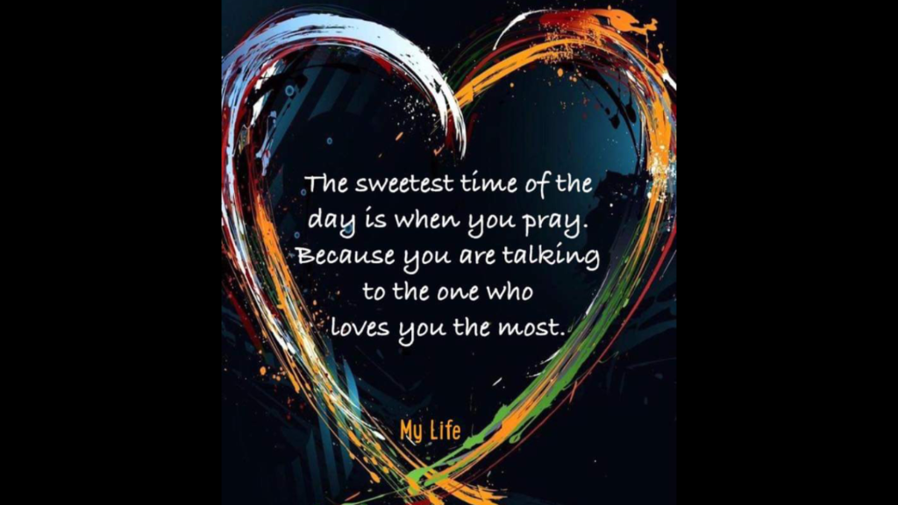

Pray that God catches you in the act of excellence!
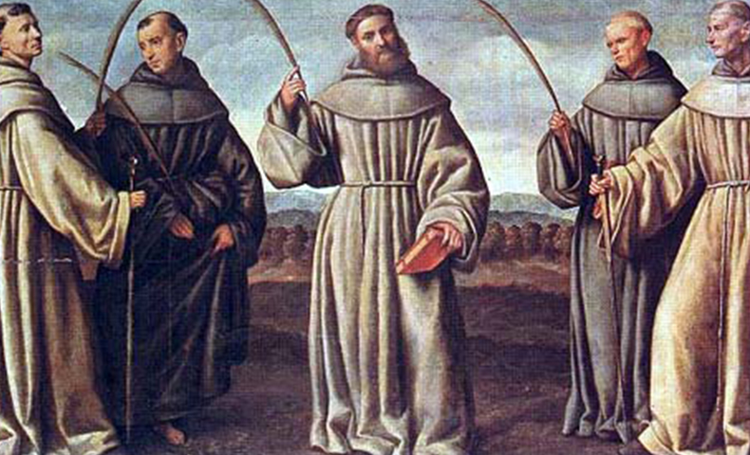
The Martyrs of Marrakesch, Franciscan Friars by Licinio Martiri

Saint Berard and Companions’ Story
Preaching the gospel is often dangerous work. Leaving one’s homeland and adjusting to new cultures, governments and languages is difficult enough; but martyrdom caps all the other sacrifices.
In 1219, with the blessing of Saint Francis, Berard left Italy with Peter, Adjute, Accurs, Odo and Vitalis to preach in Morocco. En route in Spain, Vitalis became sick and commanded the other friars to continue their mission without him.
They tried preaching in Seville, then in Muslim hands, but made no converts. They went on to Morocco where they preached in the marketplace. The friars were immediately apprehended and ordered to leave the country; they refused. When they began preaching again, an exasperated sultan ordered them executed. After enduring severe beatings and declining various bribes to renounce their faith in Jesus Christ, the friars were beheaded by the sultan himself on January 16, 1220.
These were the first Franciscan martyrs. When Francis heard of their deaths, he exclaimed, “Now I can truly say that I have five Friars Minor!” Their relics were brought to Portugal where they prompted a young Augustinian canon to join the Franciscans and set off for Morocco the next year. That young man was Anthony of Padua. These five martyrs were canonized in 1481.

Reflection
The deaths of Berard and his companions sparked a missionary vocation in Anthony of Padua and others. There have been many, many Franciscans who have responded to Francis’ challenge. Proclaiming the gospel can be fatal, but that has not stopped the Franciscan men and women who even today risk their lives in many countries throughout the world.
