Secular Franciscan Order December 2020 Newsletter

The Secular Franciscan Order was established by St. Francis of Assisi more than 800 years ago. Our purpose is to bring the Gospel to life where we live and where we work. We look for ways to embrace the Gospel in our lives and try to help others to do likewise.

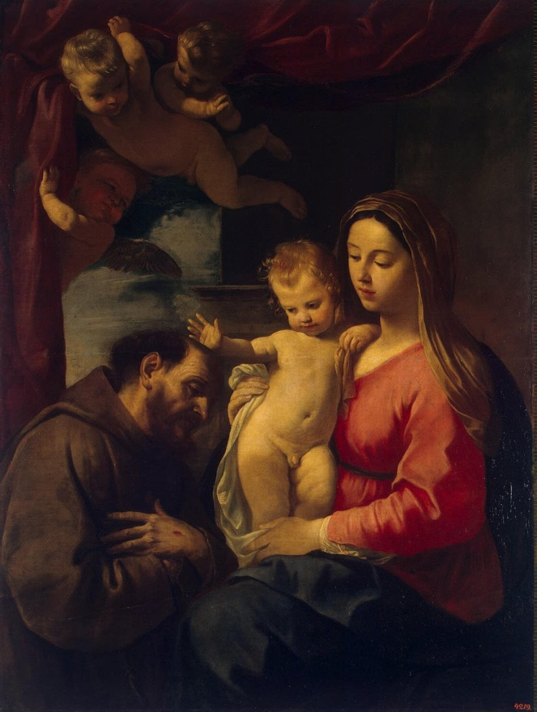

1.
our Gathering
On Dec. 5^{th,} 2020 we once again met virtually due to safety concerns relating to the pandemic. We started our gathering with the song “Mary did you Know?” assisted by You Tube. Mike shared that in year past when we could go into prison the choir at Ellis would sing this song so beautifully during the services. In prepandemic years the prisoners would be allowed one service a week and the Communion Service we would do was such a Blessing . To be allowed to bring the Body and Blood of our Dear Jesus to these men in white was such a life changing opportunity. They now do not even get to have their religious services. Let us keep all who are alone in our prayers!
Thanks to an idea from David we sent books on Christian Meditation/Centering prayer to those in Ellis as well as Ramsey. He is now in the process of ordering additional books for these men.
It was so good to see everyone (or hear). Dora had been hit harder than Mike from COVID and it was so good to have her join us virtually!
Thanks to Alan & his technical prowess we were able to watch a video from the Archdiocesan site, which was of a homily including a prayer from Fr. Drew Woods, pastor of St. Laurence in Sugarland. Amy, Alan, and Benjamin are all members of that parish.
We discussed Pope Francis Apostolic letter “Admirabile Signum” and Celanos writing on the Christmas at Greccio.
We also watched/listened to a presentation from Sr. Helen Prejean from a talk she had given at the Ignatian Spirituality Projects Company of Grace evening. Powerful!
We closed with The Franciscan Crown Rosary for Secular Franciscans: a Simple Meditation of the Seven Joys which I believe was written by our National Minister, Jan Parker…it was beautiful!
Merry Christmas and Happy New Year!
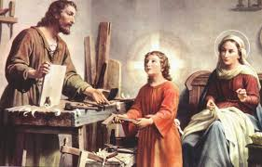 12-27-2020 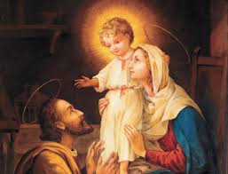

2
Merry Christmas Good People
As we come closer to celebrating the birth of our Lord and Savior Jesus Christ I reflect on what this Advent has meant to so many of us. I am sure I am not the only one who has experienced a cacophony of emotions this past year. Yet I recognize that it is through the many graces bestowed on me freely and unconditionally by our Heavenly Father that all I have to do is choose to trust in Him and allow the Holy Spirit to be my guide. For someone like me; who in my worst times could be described as ogre like, this is no easy task.
In my career as a special educator data was critical. We would have a baseline and then collect data to determine progress and efficacy. If all was implemented with fidelity we could meet our short and long term objectives and document progress.
On Jan. 4th it will be 10 years since Dora, Magdalene and I made our Permanent Profession into the Secular Franciscan Order. I wish I could say I have lived each and every day with fidelity, as stated in Article 7 of Our Rule (I should have this memorized by now):
United by their vocation as ”brothers and sisters of penance” and motivated by the dynamic power of the gospel ,let them conform their thoughts and deeds to Christ by means of the radical interior change which the gospel itself calls “conversion”. Human frailty makes it necessary that this conversion be carried out daily”.
A couple years ago I went to a retreat at Cedarbrake outside of Austin. Fr. Albert Haase OFM was the retreat master. He stated something he started relatively late in his life and that was doing a daily exxamen which begins with gratitude. He stated when he began this, his spiritual growth was strengthened.
I am so thankful for the many blessings and strength I receive from my Franciscan family as I deal with my frailty. We are truly united by our vocation as “brothers and sisters of penance”. I did not collect any data of where I was a decade ago, yet I have enough anecdotal information to show progress in my journey toward conforming my thoughts and deeds to Christ.
In a little over a month we will have our elections. At our profession we make 3 promises. The second of these includes this” Do you wish to be faithful to this vocation and to practice the spirit of service proper to Secular Franciscans?” Each of you who have professed promised to do this…..please remain open to the Holy Spirit and say yes to becoming servant leaders……trust in the Holy Spirit!
As Christmas grows nearer I am so excited that our beloved Pope Francis has dedicated this year to St. Joseph who devoted his life in perfect obedience and humility to God’s will, not his own. .
In his Apostolic Letter “Patris Corde” Pope Francis writes this:
“My desire to do so increased during these months of pandemic, when we experienced, amid the crisis, how our lives are woven together and sustained by ordinary people, people often overlooked. People who do not appear in newspaper and magazine headlines, or on the latest television show, yet in these very days are surely shaping the decisive events of our history. Doctors, nurses, storekeepers and supermarket workers, cleaning personnel, caregivers, transport workers, men and women working to provide essential services and public safety, volunteers, priests, men and women religious, and so very many others.

3
They understood that no one is saved alone… How many people daily exercise patience and offer hope, taking care to spread not panic, but shared responsibility. How many fathers, mothers, grandparents and teachers are showing our children, in small everyday ways, how to accept and deal with a crisis by adjusting their routines, looking ahead and encouraging the practice of prayer. How many are praying, making sacrifices and interceding for the good of all ……
Each of us can discover in Joseph – the man who goes unnoticed, a daily, discreet and hidden presence – an intercessor, a support and a guide in times of trouble. Saint Joseph reminds us that those who appear hidden or in the shadows can play an incomparable role in the history of salvation. A word of recognition and of gratitude is due to them all.” …..
Pope Francis than goes on and finishes with this:
“We need only ask Saint Joseph for the grace of graces: our conversion.
Let us now make our prayer to him:
Hail, Guardian of the Redeemer,
Spouse of the Blessed Virgin Mary.
To you God entrusted his only Son;
in you Mary placed her trust;
with you Christ became man.
Blessed Joseph, to us too,
show yourself a father
and guide us in the path of life.
Obtain for us grace, mercy and courage,
and defend us from every evil. Amen”.
Given in Rome, at Saint John Lateran, on 8 December, Solemnity of the Immaculate Conception of the Blessed Virgin Mary, in the year 2020, the eighth of my Pontificate.
Franciscus“

Amen !
Peace
michael
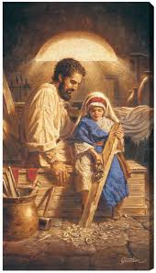
Year of St. Joseph
12-8-2020 / 12-8-2021

4
Next Meeting: January 2nd, 2021
10:00 a.m. via ZOOM
Candidates & Inquirers in Formation: check your emails for more information
Our Gathering will be via Zoom
Look for an email from Mike Freeman for log-in information.
First ZOOM information email sent 12-19-2020

Prepare to share (2-3 minutes) your favorite Gospel Parable
& how it speaks to you!

Patris Corde means “With a Father’s Heart”

We are continuing the SUNDAY Meal Sign Up for Deacon Louis & Jean Horr.
See email on 11-19-20 from secretary.StMaxSFO@gmail.com

Alba ordered some F.U.N. Manuals (For Up to Now – Foundational Topics for Initial Formation). They do not come with a binder. Purchase price is $13/ea.

$$$ Continue to save money for our contribution bag when next we meet in person.
Cash or checks made payable to: St. Maximilian Kolbe Fraternity.

Regional Crown Rosary will be prayed together via ZOOM each month on the 4th Sunday @ 2:00 p.m. If interested in being included in receiving ZOOM information, please contact Cherryle Fruge, OFS, Minister-St. Joan of Arc Region
cherrylefruge@msn.co

A Spanish version of the TAU-USA is now available and being mailed to Spanish speaking members upon request. Email your name, address, fraternity name & region name to:
Cindy Wesley OFS, cw93444@gmail.cm Or mail request to:
Cindy Wesley OFS
846 Calimex Place
Nipomo, CA 93444

5

Every Day for PRAYER!

There are LOTS of ways to become involved.
Reference emails from Ryan @ secretary.StMaxSFO@gmail.com and emails from Michael @ mbigfree@aol.com for specifics!

February 2021 Meeting of the New Year will be 2-6-2021

Mary gave her Fiat to God. St. Joseph gave his Fiat to God.
Will YOU give your Fiat to God?

There are 2 ways to GET ENOUGH. One is to continue to accumulate more & more. The other is to DESIRE LESS!
G.K. Chesterton

6
Mary – 365 Days

When we talk about justice, we tend to limit our thinking to legal action in a court of law. We believe that justice is done when criminals are convicted, and crimes punished.

When we talk about charity, on the other hand, we generally refer to acts of kindness to the less fortunate. We think of charity as giving a donation to a worthy cause or a handout to a street person.

The Hebrew Scriptures take a radically different view of these two words. What we call charity, it calls justice.

Mary stands as a living example of this scriptural interpretation of justice. The woman who announced to her son, “They have no wine,” isn’t afraid to go boldly before the throne of God to say, “They have no food, no home, no job.” Completely absorbed by our human condition and human struggle, she prays now and always for our broken and confused world. But more than that, she devotes herself to praying for the forgiveness of sin. As an Orthodox Church prayer says, “O Mary the Virgin Theotokos, the holy and trusted intercessor of the human race, intercede for our sake before Christ, whom you bore, that He may grant us the forgiveness of our sins.”

As you go about your daily life, do you see people in need of food, clothing, shelter, and forgiveness? If so, don’t give them a token in the name of charity; give them all you can in the name of justice.
In what ways do I promote justice in the world?
Could I do more than I’m doing?
I EXECUTE JUSTICE – AND I DO SO CHARITABLY!

7

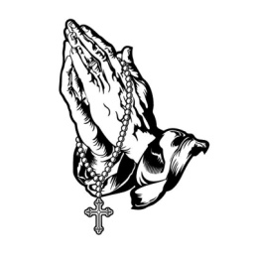
Remain in prayer for:

Healing prayers for Michael Freeman & his diagnosis of prostate cancer

Thanksgiving Prayers of healing from COVID for Mike, Dora & Jude Freeman

Healing prayers for Consuelo Davis

Healing Prayers continue for Joan & Deacon Louis Horr

Fr. Mike requests prayers for all who have died due to COVID-19 and all who have been infected

Claire Dwyer: pray for her daughter Shannon, suffering from anxiety & depression.

Continued prayers for Alan Allen, his fellow coworkers & all seeking sustainable employment! Pray for peace, patience & renewed hope.

Continued success for Alan & Fabiola in their ministry of YouFra.

Ryan Efaw, Caitlyn & child: Expected due date is May 24, 2021! Pray for good health for mother, child and of course, daddy!

Pray for Fr. Stephen Arabadjis & all priests & seminarian in the Society of St. Pius X.
May they recognize God’s Will for their lives & be open to His direction.

Pray for all Holy Priests and Seminarians throughout the world.

Pray for Martha Restrepo (healing of eyes), her Husband Holbein (cancer treatments) &
son in law Deacon Robert Trahan (bypass surgery & good heart health)

Remember to email Ike ecolleton@comcast.net for prayer requests to be included in Newsletter

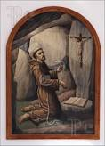

Make sure you make room in The Rule for THE RULER!
8

