Secular Franciscan Order march 2019 Newsletter

The Secular Franciscan Order was established by St. Francis of Assisi more than 800 years ago. Our purpose is to bring the Gospel to life where we live and where we work. We look for ways to embrace the Gospel in our lives and try to help others to do likewise.

2019 is the 41st year of our current Rule approved in 1978!

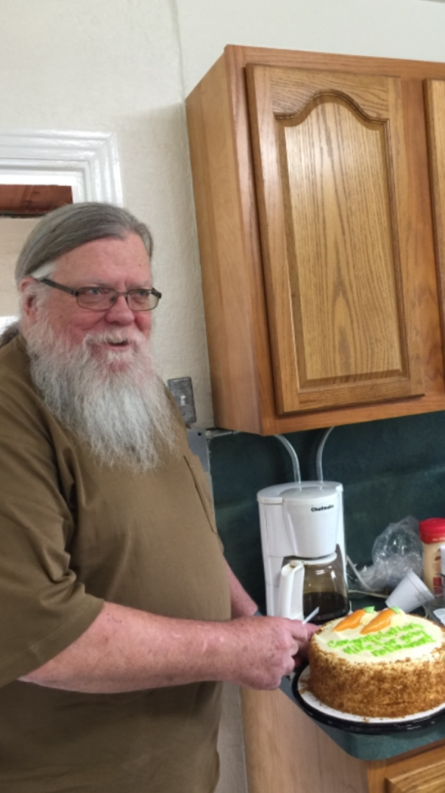
HAPPY RETIREMENT MICHAEL FREEMAN, OFS

Our Gathering
March 2nd, 2019 Dora Freeman, OFS began our gathering by leading us in The Liturgy of the Hours followed by an inspiring reading from “The Little Flowers of St. Francis of Assisi” by Danny Marquer, OFS. Danny continued by prayed our candle prayer for the three orders of our Franciscan Family; past, present and future. Michael Freeman, OFS lead us in our Ritual of the Secular Franciscan Order, page 35. Those present at our February Gathering were given an admonition or prayer strip with a matching Scripture and asked to bring the admonition into our personal prayer time, asking Our Lord to direct our heart and open our mind to what God might be calling us to. We spent a few minutes sharing our experiences with the admonitions we had received last month. It was a beautiful sharing with lots of insight and graces received.

Danny Marquer, OFS read Rule #10 “From Gospel to Life”. He presented a short teaching on the Rule, sharing his thoughts and interpretation. All were invited to add their own thoughts to the discussion.

Ryan Efaw, OFS presented a short teaching on the Gospel of Matthew, 3:1-12 and Matt 10:36. He shared his wealth of knowledge & personal experiences using sources such as the Words of Jesus, St. Francis, St. Mother Teresa, Franciscan Media, and Ascension Presents.

We took a short break and indulged in the delicious goodies all brought to share. (I’m still full!) Yummo!

We regrouped and Michael Freeman, OFS played a CD for us to contemplate. The Way of St. Francis: Teachings & Practices for Daily Life. It was the voice of Fr. Murray Bodo, OFM, PhD speaking on the disenfranchised. The challenge is to keep our eyes & hearts open, to see as St. Francis saw, to see with the eyes of Christ. The content was sobering to say the least. Very thought provoking, Fr. Bodo ended by giving a short history of the Canticle of Brother Sun which St. Francis wrote 2 years before his death in the year 1224. He recited the Canticle prayerfully and with much emotion.

Michael Freeman, OFS led us in the Closing Prayer from the Ritual of the Secular Franciscan Order, page 36. He reminded us that March 4th is our 18th Birthday! Happy Birthday St. Maximilian Kolbe Fraternity!

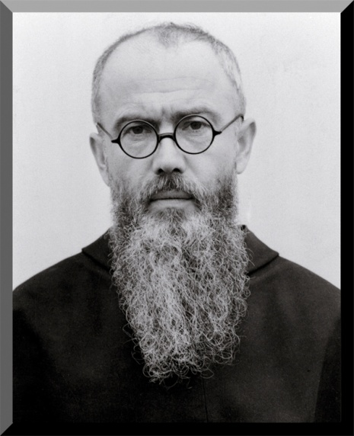
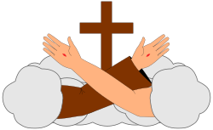

Rights and Responsibilities

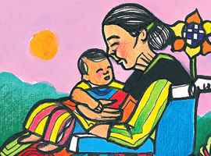
The Catholic tradition teaches that human dignity can be protected and a healthy community can be achieved only if human rights are protected and responsibilities are met. Therefore, every person has a fundamental right to life and a right to those things required for human decency. Corresponding to these rights are duties and responsibilities--to one another, to our families, and to the larger society.
USCCB

I had to chuckle out loud when I paused and said what a long month it has been. Yes Michael…..31 days! Yep, three days longer than last month. We had our monthly gathering, went to the Regional Executive Council gathering, Dora and I went to the Hill Country for a day of Reflection, attended a Correctional Ministries Retreat, Caritas Day, participated in an Ignatian Spirituality Retreat to end homelessness, and finally Advocacy Day. We had a wonderful turn out for Caritas Day. We prepared enough for 2000 meals which were donated to St. Vincent DePaul along with the remaining beans half ton of beans. The opened packages made their way to Casa Juan Diego.Thanks to all for everything! It was made even more special by Alan and Dustin bringing their children to work along side of us. For Advocacy Day we again had a bus leave St. Jerome’s. We were 1 of 3 buses the Archdiocese provided and we broke into 3 teams to meet with our elected representatives and share packets our Bishops had prioritized for this Legislative session. We were again Blessed by young people…..21 students from St. Pius High School and their chaperones went with us. And, knowing there are no coincidences, 5 of them were on the team with us who visited State Representative Johnson…..who has a son at St. Pius and they all knew him !
So, what does all this have to do what I copied off the USCCB site? Responsibility. All of us have been called by our Baptism to go out and spread the Good news During the time of our Initial Formation we learned that the principal agent of Formation is The Holy Spirit, immediately followed by ourselves. When we professed we all promised to live by our Rule . This requires participation in fraternity and its apostolates. This is our responsibility. This quote comes directly from the National Spiritual Assistants Handbook “, the SFO must be recognized as an autonomous Franciscan Order within the communion of the Franciscan Family, and necessary for the fullness of the Franciscan charism.”
It continues with “Each activity of a single fraternity within the Franciscan Family has or could have consequences for the whole Family”. Yikes! .What we do, or do not do individually has an impact. We, Like Francis, have been called to rebuild the Church. This document continues and reads, “They have been made living members of the Church by being buried and raised with Christ in baptism; they have been united more intimately with the Church by profession. Therefore, they should go forth as witnesses and instruments of her mission among all people, proclaiming Christ by their lives and words. Called like Saint Francis to rebuild the Church and inspired by his example....”84
We find the same directives in the General Constitutions: “Called to work together in building up the Church as the sacrament of salvation for all and, through their baptism and profession made ‘witnesses and instruments of her mission,’ Secular Franciscans proclaim Christ by their life and words. Their preferred apostolate is personal witness in the environment in which they live and service for building up the Kingdom of God within the situation of this world.”85
Active participation in fraternal life is necessary. The National Spiritual Assistants go to our own documents:
Lay Franciscans find in the fraternity “the privileged place for developing a sense of Church and the Franciscan vocation and for enlivening the apostolic life of its members.”89 Through life in fraternity they are sent, in the Church and with the Church, together with all persons of good will, to all humanity in order to “build a more fraternal world,”90 and bring about “universal kinship”91 with all creatures in an attitude of respect and appreciation, according to the plan of God, the Creator and Lord of all things.
To be a Secular Franciscan there are responsibilities. “On this subject the General Constitutions say: “The sense of co-responsibility of the members requires personal presence, witness, prayer and active collaboration, in accordance with each one’s situation and possible obligations for the animation of the fraternity.”128 Fraternal life is so important that this is the only article of the Constitutions in which we find such a strong verb: “requires.” All the other articles use an exhortatory form, not the imperative.
We are each co responsible. As we do our Daily Examen or after evening prayer, let us ask ourselves, am I fulfilling my responsibilities as a Franciscan?
Responsibility.
Peace
Michael

CARITAS DAY IN HOUSTON, TEXAS 3-16-19
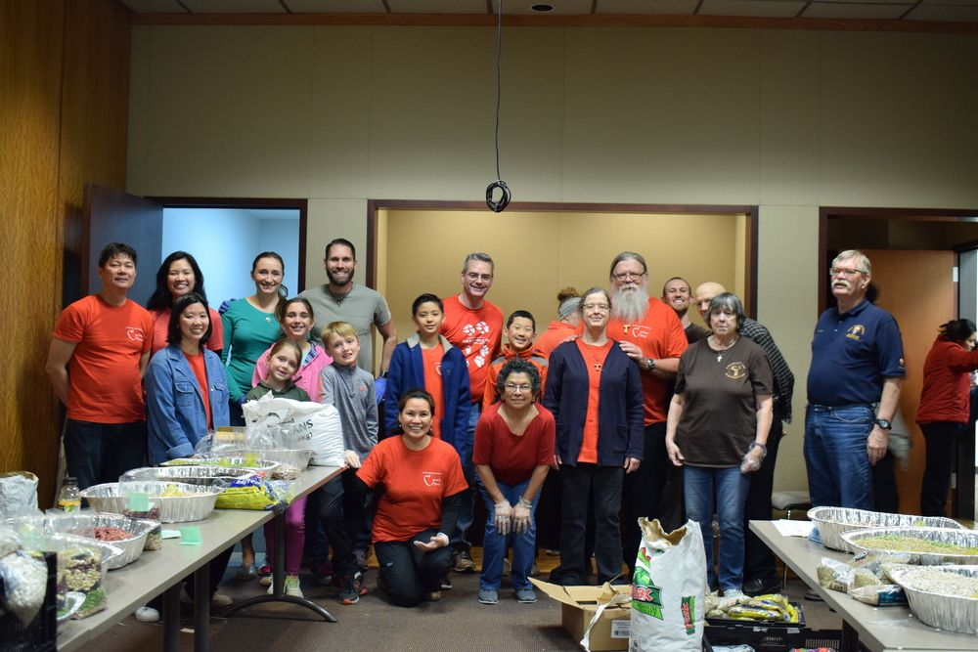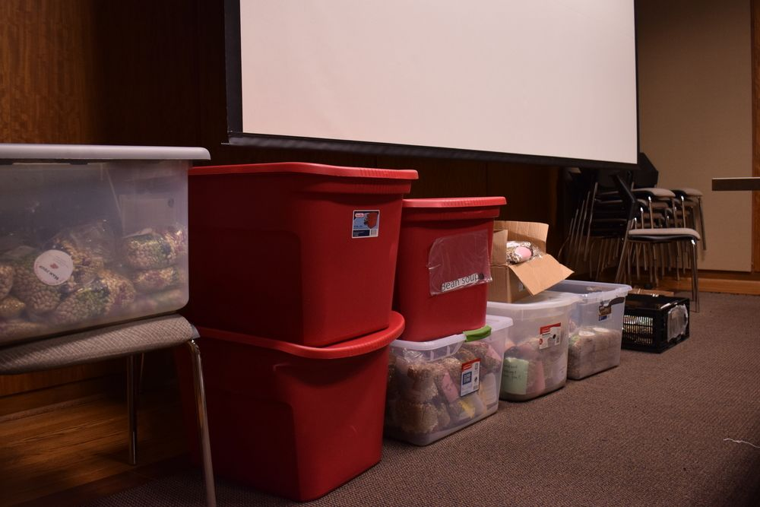
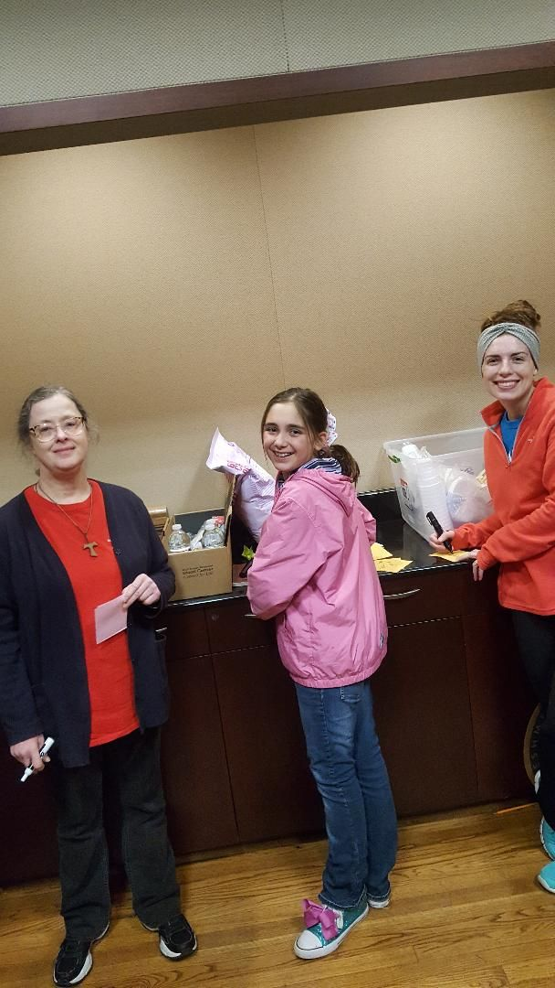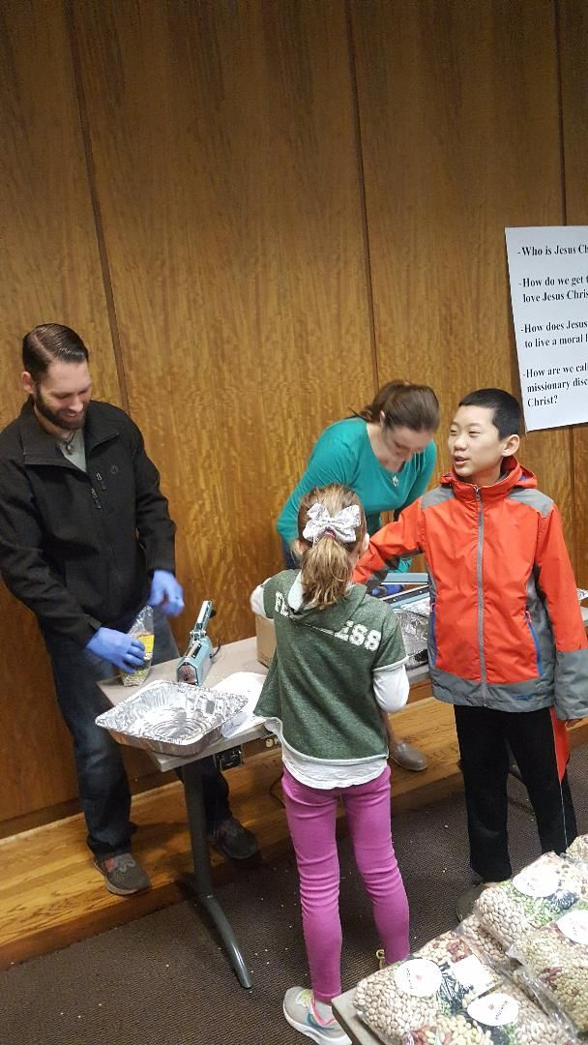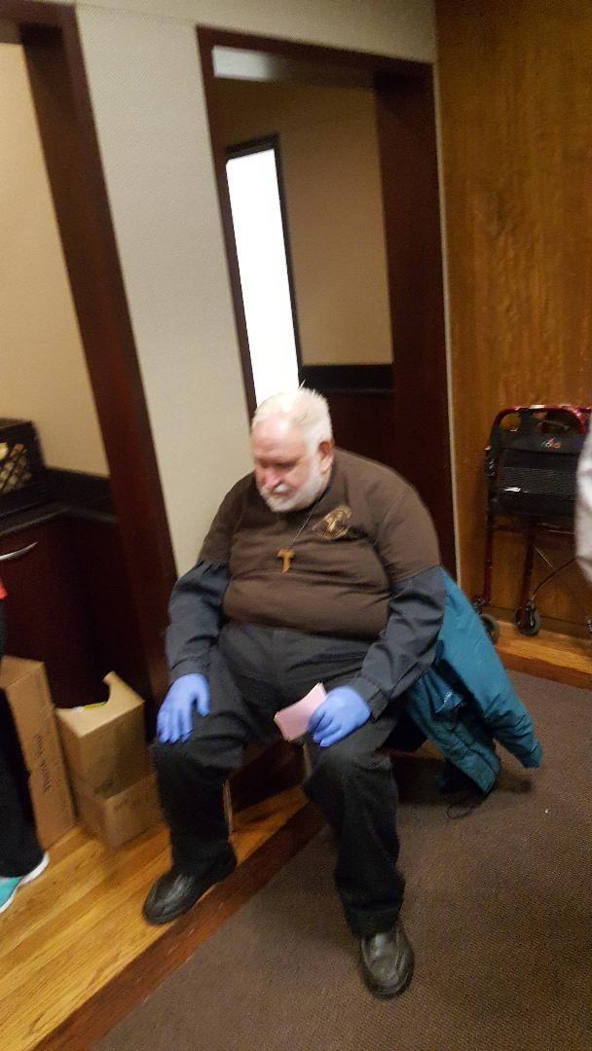
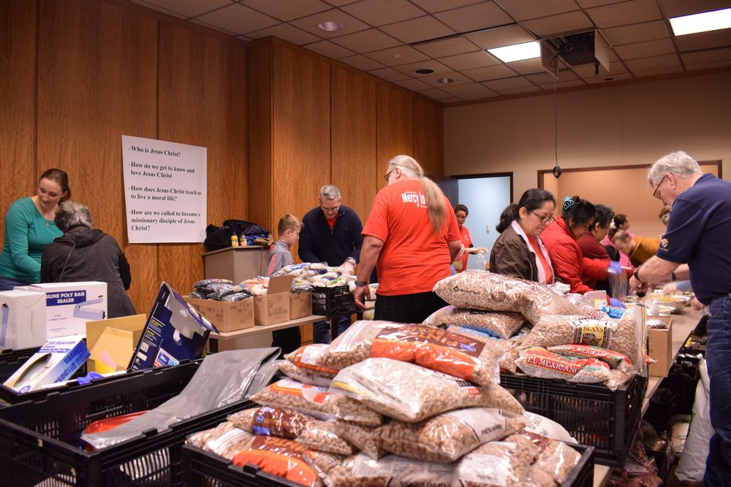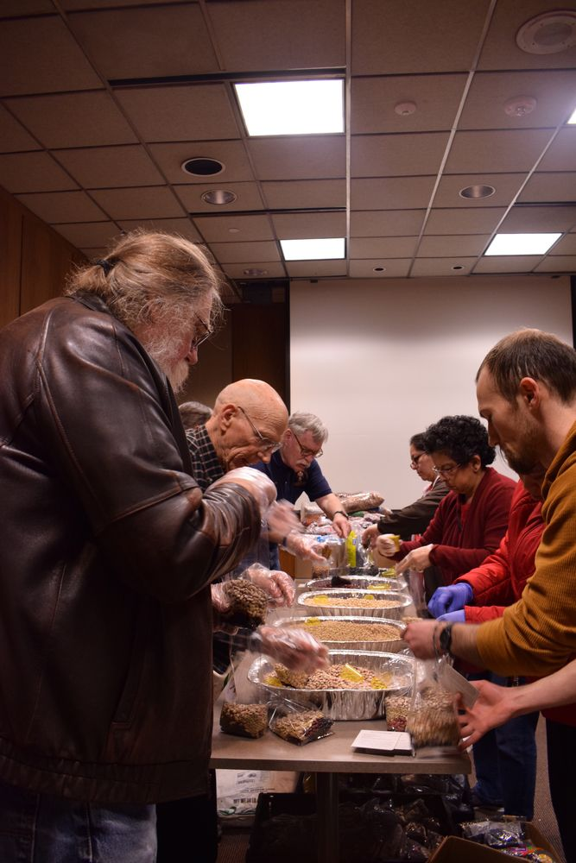
ADVOCACY DAY IN AUSTIN, TEXAS 3-26-19
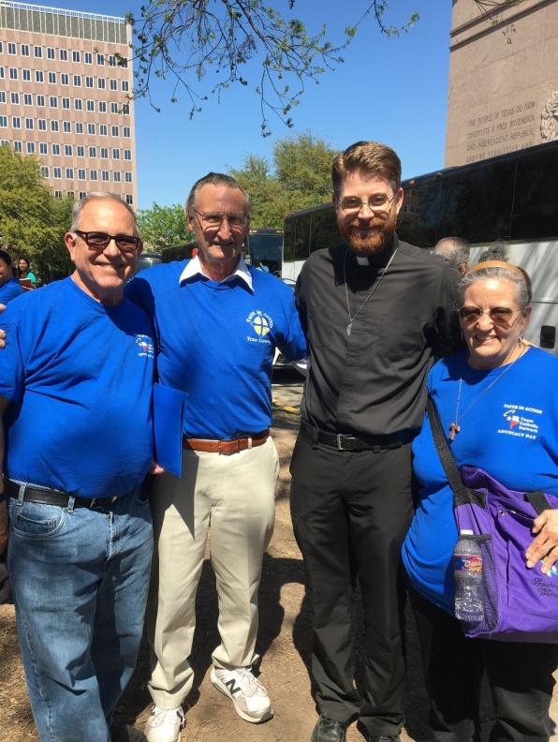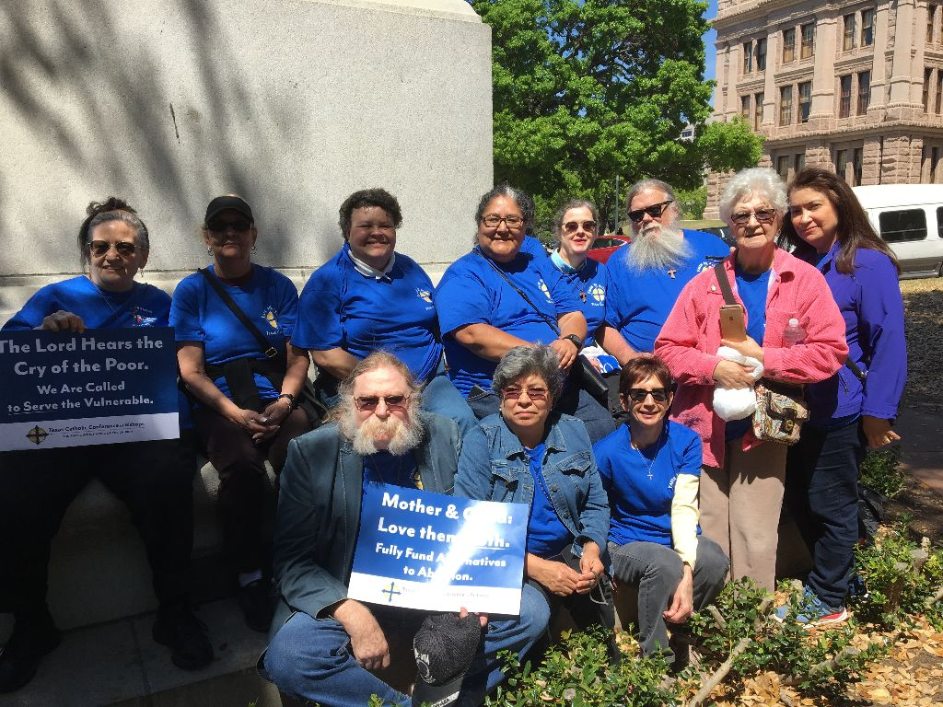

Next Meeting: April 6th, 2019 beginning @ 10:00 a.m. in
St. Jerome Catholic Church: In the Outback Building
Bring your Liturgy of the Hours.
Early Birds: An opportunity to join together in The Holy Mass in the day chapel @ St. Jerome beginning 8:15 a.m.
Candidates and Inquirers Formation begins @ 9:00 a.m. in the Outback!
Adoration by Candlelight @ St. Mary’s Seminary Chapel * 9845 Memorial Dr.
Every 4th Monday of the month @ 7:00 p.m.
September 23rd, October 28th, November 25th
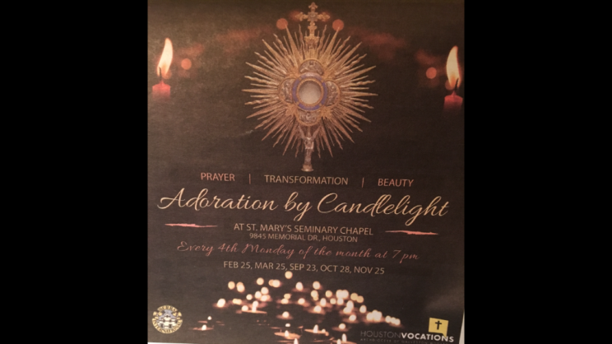
ALL ARE INVITED

Regional SFO Retreat: Friday May 3rd – Sunday May 5th. Moss Point, LA

FOR MORE INFORMATION ABOUT EVENTS, PLEASE REFER TO E-MAILS FROM secretary.StMaxSFO@gmail.com

Excerpt from Daily Guideposts Sunday March 10th, 2019
Though I walk in the midst of trouble, you preserve me against the wrath of my enemies; you stretch out your hand. Psalm 138:7 (NRSV)

I worry. What if there’s a long line and we miss the beginning of the show? What if it rains? I don’t so much fret as sweat about the health of my kids, the happiness of my marriage, the future of the company I work for. Only when I looked into the life of Francis of Assisi did my perspective begin to change.

One day Francis was traveling on foot with a friend. Noticing Leo was bothered by the cold and freezing rain, Francis said, “What do you think is the source of joy?” Annoyed, Leo walked more briskly. Francis spoke again a few minutes later, “There’s no joy in great theology!” For two miles, this went on. Leo walked, ignoring Francis; Francis talked to his friend, who pretended not to listen.

Finally Leo stopped, spun around, and said, “So what’s the source of joy?”

“When we arrive,” Francis said, “our cloaks drenched by rain, our bodies shivering with cold, and we knock at the door, if our host says, ‘Wait outside awhile’ – if we bear all of this with patience, kindness, and love, we will be brimming with joy”.

Now I practice replacing my worries with faith. I try fasting on special days, especially this time of year. I focus on any discomfort I experience and realize its unimportance. By making my perspective shorter, looking ahead less often, and living each moment more fully without worry, I become a part of God’s larger perspective and learn to accept that with joy.
You, God, are my hope today!
Jon M. Sweeney

Digging Deeper: 1 Thessalonians 5:5-6

